**HIV SELF TESTING AMONG KEY & VULNERABLE POPULATIONS AND LINKAGES TO CONTINUUM OF CARE AND SUPPORT: “BHUTAN SELF-CARE” PROJECT**

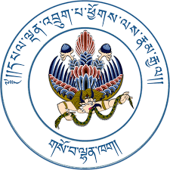

**National HIV, AIDS & STIs Control Program**

**Department of Public Health**

**Ministry of Health**

**Supported by:**

Multi-Country Regional SKPA Global Fund Grant through Save the Children Bhutan and Australian Federation of AIDS Organization.



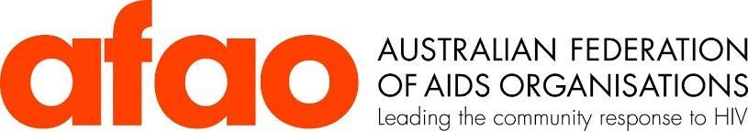

Contents

Research Team 4

List of acronyms and definitions 6

Background 8

Oraquick® Rapid HIV Self-Test 10

Testing Algorithm 11

Project Objectives 12

Research Design and Methods 12

Operational definitions 14

Study setting 15

Target population 15

Sample size and recruitment process 15

Project Implementation Process 17

Results & Findings 18

SECTION ONE: KEY POPULATION . 18

A. DEMOGRAPHIC OF THE RESPONDENTS 18

B. GENDER & SEXUALITY 22

C: SEXUAL RISK BEHAVIOR 23

D: HIV TESTING AND PREVENTION 26

E: STIGMA & DISCRIMINATION 29

F: MEMBERSHIP OF NGO 29

G: HIV SELF TESTING UPTAKE 29

H. QUALITATIVE FINDINGS: 30

Gender & Sexual Identity 30

Mode of recruitment 31

Health problems 31

Problems associated with availing health services for key population 31

Initial feeling before availing the HIVST service 32

Understandability of the information 33

Decision to participate in the study 33

Opting for HVST by friends and peers 34

General opinions of respondents 34

Improving Services for Key Populations 34

**SECTION TWO: VULNERABLE POPULATION** 35

A. DEMOGRAPHIC OF THE RESPONDENTS 35

B. GENDER & SEXULAITY 36

C: SEXUAL RISK BEHAVIOR 36

D: HIV TESTING AND PREVENTION 39

E: STIGMA & DISCRIMINATION 39

F: MEMBERSHIP OF NGO 39

G: HIV SELF TESTING UPTAKE 39

H. QUALITATIVE FINDINGS 39

Demographics of Participants 39

Health issues 41

Access to health services 41

HIV test among participants done in the past 42

Suggestions to resolve the challenges 43

Many participants suggested some solutions to the challenges and improving the services of HIV/AIDS services. 43

Reasons for participating in the demonstration project 44

Initial feeling 45

Testing Method 46

Understanding of Instructions 46

Experience of testing 46

Willingness to avail HIVST in future 47

Participation of friends/peers in the testing 48

Discussions 49

Study Limitation 50

Recommendations 50

Conclusions 51

# Research Team

Principal Investigator:

Lekey Khandu, National HIV, AIDS and STIs Control Program, Dept. of Public Health, Ministry of Health, Thimphu, Bhutan.

Co-Investigators:

1. Dolley Tshering, National HIV, AIDS and STIs Control Program, Dept. of Public Health, Ministry of Health, Thimphu, Bhutan.
2. Jigme Thinley, National HIV, AIDS and STIs Control Program, Dept. of Public Health, Ministry of Health, Thimphu, Bhutan.
3. Choki Dolkar, National HIV, AIDS and STIs Control Program, Dept. of Public Health, Ministry of Health, Thimphu, Bhutan.
4. Karma Doma Tshering, Save the Children, Thimphu, Bhutan.
5. Jamyang Norbu, Save the Children, Thimphu, Bhutan.
6. Dr. Tashi Dendup, Save the Children, Thimphu, Bhutan.
7. Tenzin Gyeltshen, Pride Bhutan, Thimphu, Bhutan.
8. Dr. Tashi Tobgay, Institute of Health Partners, National Consultant, Thimphu, Bhutan

**Roles of the Investigators**

|  |  |
| --- | --- |
| **Principal Investigator (PI)**   * To guide the overall proposal development and implementation of the project activities * To mobilize funds and logistics of research * To recruit local staff and participants * To obtain permission including ethical approvals * To assist technical advisors in providing local information and data related to the subject matter * To ensure smooth conduct of the project | **Co-Investigators**   * To assist the PI in all matters about the project * To participate and contribute in the proposal development and implementation of the project * To support PI and other advisors in terms of information gathering, obtaining approvals, and other activities related to the study |

**Implementing partners**

|  |  |
| --- | --- |
| **MOH**   1. Lead the implementation of the demonstration project with the key implementing partners HISC and CBOs. 2. Responsible for the development and dissemination of HIVST implementation manual and supporting tools 3. Facilitate the HIVST kit distribution in collaboration with partners 4. Regularly monitor, review and support the overall implementation of the program | **HISCs & (Pride Bhutan)**   1. Coordinate and support the implementation of HIVST 2. Regularly monitor the consumption of the HIVST kits and manage the supply 3. Monitor and support the recording and reporting activities 4. Lead and support the monitoring of the implementation through joint supportive supervision and performance review at designated cities. 5. Review and support the overall implementation of the program 6. Advocate for use of HIVST to increase testing among partners of PLHIV and targeted key populations. 7. Provide correct use and other related information |
| **SKPA & Partners**   * Collaborate with the MoH, agencies, and regional health bureaus in the planning, coordination, implementation, and programmatic management of HIV self-test (assisted and unassisted) * Provide the necessary technical and financial support for the development and duplication of materials * Support the monitoring of HIVST implementation along with the national and regional offices | |

# 

# List of acronyms and definitions

AIDS Acquired Immunodeficiency Syndrome

ART Antiretroviral Therapy

ARV Antiretroviral (drugs)

BHU Basic Health Unit

BSC Bhutan Self Care

CSO Community-Based Organization

CSW Commercial Sex Worker

CPA Chithuen Phendhey Association

DOPH Department of Public Health

FSW Female Sex Worker

HISC Health Information Service Centre

HIV Human Immunodeficiency Virus

HIVST Human immunodeficiency virus Self-Test

HMIS Health Management Information system

HRW High Risk Woman

5C Consent, Confidentiality, Counselling, Correct Results and Connection

JDWNRH Jigme Dorji Wangchuck National Reference Hospital

KP Key Population

MoH Ministry of Health

MSM Gay men and other men who have sex with men

NACP National HIV/AIDS and STI Control Program

NGO Non-Governmental Organization

NSP National HIV, AIDS and STI Strategic Plan 2017-2023

ORW Outreach worker

PHC Primary Health Centre

PICT Provided Initiated Counselling and Testing

PEP Post-Exposure Prophylaxis

PMTCT Prevention of Mother-To-Child Transmission

PORW Peer Outreach Workers

PrEP Pre-Exposure Prophylaxis

PWID People who inject drugs

PWUD People who use drugs

SKPA Sustainability of HIV Services for Key Populations in Asia Program

STI Sexually Transmitted Infection

TOT Training of Trainers

TG Transgender

TGM Transgender Man

TGW Transgender Woman

UNAIDS Joint United Nations Program on HIV/AIDS

UHC Universal Health Coverage

VCT Voluntary Counselling and Testing

VL Viral Load

WHO World Health Organization

Executive Summary

In Bhutan, existing data suggest a low-level HIV epidemic. The first case of HIV was diagnosed in 1993. Since then, the number of new infections diagnosed increased steadily. The number of new HIV infections appears to have plateaued since 2013 fluctuating between 49 and 58. As of November 2021, there has been an accumulated 795 HIV diagnoses and 599 of the cases are known to be alive. According to Global AIDS Epidemic modeling by UNAIDS based on data from 2018, the projections model reveals increasing HIV infectivity trends in Bhutan among key populations with an HIV detection gap of about 39%. As part of the SKPA program, an external review of key population service packages and gender review was conducted that also outlined the requirements of increasing HIV testing uptake through innovative strategies. As per the national Key Populations Size Estimate study (PSE), the size estimates of the key populations were calculated. There are an estimated 1,221 high-risk women in Bhutan, of whom 597 are commercial sex workers. There are an estimated 1,726 men who have sex with men, 76 transgender women, and 302 transgender men. Various reviews conducted by WHO, Global Fund, and other partners have recommended focusing on scaling up testing for the key populations.

HIV-Self Testing (HIVST) is becoming an established option for providing highly accurate results and is recommended by WHO particularly to provide testing services to key populations, who remain mostly hidden. HIVST is a process of testing HIV where a person collects his or her specimen (oral fluid or blood) and then performs the test and interprets the test result, often in a private setting, either alone or with someone he or she trusts. For this demonstration project, only an oral fluid sample is used. It is a screening test and does not provide confirmatory diagnosis and therefore confirmatory testing is required if the initial result is positive. An individual conducts his or her own HIV test using a simple oral test kit. This emerging testing approach provides an opportunity for people to test themselves discreetly and conveniently, thereby empowering those who may not otherwise test willingly, particularly among high-risk populations to know their HIV status. Despite considerable efforts, there remains a testing gap for the country and new approaches must be considered. HIVST has the potential of being a high-impact, low-cost intervention to reach population groups that are not testing and to increase the number of people living with HIV who are identified and initiate treatment. HIVST also provides an opportunity to link HIV prevention services with the people who are tested negative.

To provide focused interventions and also to increase detection rate, the MOH in collaboration with Save the Children, Bhutan, carried out a Bhutan Self Care demonstration project, to understand the feasibility of the HIVST in Bhutan. “OraQuick” test kit (WHO pre-qualified and registered with DRA) was used for this project. The demonstration project was carried out among the target key and vulnerable population using both qualitative and quantitative data collection methods. A total of 436 key population members and 447 vulnerable population members were tested using various methods. There were no reactive results. Despite having some nervousness and fears before and while waiting for the test results, most participants believed that the test is simple, easy, and can be useful to self-test HIV. The study found that HIVST can be implemented in Bhutan and can be one of the strategies particularly to reach the unreached and the hidden key population. However, there should be adequate advocacy, enhanced access to counseling services to prevent any ill effects, and access to HIVST kit should be made freely available across the country.

# Background

INTRODUCTION

HIVST has the potential to increase understanding of HIV status and has public health benefits that may significantly reduce the risk of HIV transmission. Bhutan aims to achieve the target of 95-100-95. This demonstration project is envisioned to enhance uptake and allow easier accessibility of HIV testing options for the key and vulnerable populations. As there is low uptake of conventional HIV testing in the country, it is important to implement innovative strategies to widen the scope of nationwide HTS provision. The development of this HIVST demonstration project was therefore necessitated by the need to increase the uptake of HIV testing in the country. Increased HIV testing can support HIV prevention, care, and treatment services. HIVST provides an opportunity for people to test themselves discreetly and conveniently and may provide an opportunity to the population currently not reached by existing HIV testing and counseling services. Thus, the introduction of HIV self-testing in addition to already existing testing methods can significantly contribute to the national objective.

COUNTRY’S CONTEXT & RATIONALE

The national response to HIV in Bhutan is geared to end the epidemic by 2030. Targets to achieve this vision include increasing the proportion of the population living with HIV who are diagnosed to >95%, the proportion of those diagnosed on antiretroviral treatment at 100%, and the proportion retained in care with sustained viral suppression at >95% by 2025. In contrast to other countries in Southeast Asia, Bhutan has a different epidemiologic progression of HIV with infection appearing relatively later. Typically, key populations are at elevated risk to acquire infections but there is very low HIV testing uptake in this group. These key populations include men who have sex with men, transgender persons, female sex workers and high-risk women, and people who use drugs. HIV incidence rises fast in these populations, often accelerating after a threshold of 5% prevalence. HIV transmission to the sexual partners and spouses of key population members becomes substantial, raising the overall prevalence of HIV for the nation.

At present, in Bhutan, HIV testing and counseling are provided through 49 hospitals, 186 PHCs, six HISCs and 13 private diagnostic clinics. In addition, targeted HIV & STIs (hepatitis B and syphilis) testing is carried out, through the outreach and in-reach activities from the six standalone HISCs for key populations including the vulnerable populations like migrant and transport workers.

Out of 658 cases that were analyzed for a mode of transmission[1],612 (92.2%) cases were reported with the heterosexual model of transmission, 37 (5.6%) – mother to child transmission (MTCT), 3 (0.5%) – injecting drug use (IDU)-related transmission, 3 (0.5%) – as a result of blood transfusion, 3 (0.5%) – other reasons (not specified). The recent data, from NACP, for the HIV cases till November 2021 also indicates the sexual route of transmission (749 cases) followed by Mother to Child (40), IDU (3) and blood transfusion (3). Based on the existing data, heterosexual transmission is the predominant mode of HIV transmission; however, cases of homosexual sex may be underreported due to the high level of stigma associated. Chances are high that those missed for HIV testing are the more stigmatized population groups which could also potentially contain undiagnosed HIV cases. Current approaches have not yielded an adequate level of testing among the key populations. The low number of outreach referrals points towards stigma and discrimination and other issues of confidentiality that key population groups often encounter.[2]

A recent population size estimation exercise conducted among men who have sex with men, transgender persons, and sex workers in Bhutan lays the foundation for this HIV self-testing implementation. The exercise applied multiple methods to arrive at robust population size estimates, mapped the venues where key populations can be reached, and gauged their levels of risk and preventive behaviors through face-to-face interviews. The study successfully recruited 948 key population members (including 349 sex workers, 273 men who have sex with men, 34 transgender women, 124 transgender men, and 168 other high-risk women) using a hybrid venue / peer-referral sampling approach. Synthesis of the several population size estimates and extrapolation arrived at an estimated 1,726 men who have sex with men, 597 sex workers, 76 transgender women, 302 transgender men, and 624 other women at high risk (i.e., entertainment workers). Interview data found high levels of risk behaviors (e.g., sex for money, multiple partnering, early sexual debut, sex with alcohol) coupled with low levels of preventive behaviors (e.g., condom use, HIV testing, receiving prevention outreach) and wide experiences of discrimination and stigmatization of key populations.

Major factors driving new HIV infections in Bhutan include lack of knowledge on HIV status in heterosexual relationships, inadequate information on unprotected sex, and low uptake of HIV prevention services including consistent low condom use. Bhutan has not previously implemented self-testing or community-based testing through community-based outreach workers. The draft community-based HIV testing details the provision of confidential and voluntary HIV testing services through a community-based continuum of prevention & support sites[3]. It states the principles of 5Cs (Consent, Confidentiality, Counselling, Correct Results, and Connection) or HIV testing (as per WHO Guideline, 2015).

The need to scale up HIV testing services (HTS), including counseling, pre-test information, and post-test counseling; linkage to appropriate HIV prevention, care, treatment services, and other support services are promoted. The recent review of HIV/AIDs services by various technical partners reinforced the need to strengthen the diagnostic and care services with a particular focus on key populations. Therefore, a comprehensive service package inclusive of HIVST services is drafted. HIVST offers privacy and could be done alone or with someone they trust using an oral fluid test kit. Oral fluid-based test kit (OraQuick)[4],[5] can be either administered by trained peer outreach workers or by individuals. Introducing HIVST may further reduce the burden/load on the Health Information and Service Center (HISC) and prevent delays in diagnosis and treatment. HIVST projects had been successfully implemented in Nepal and other regional countries[6],

This demonstration project has leveraged the materials and institutes established for population size estimate study, and sentinel surveillance. The tools and narrations are aligned and adapted from the population size estimate study, sentinel surveillance study, to make it easier for the peer outreach workers as this study has also used the same peer outreach workers. In addition, this demonstration project adapted methods from similar studies conducted in Nepal and other WHO guidance documents.

WHO recommends[7] differentiated HTS delivery which includes facility-based testing, self-testing, community-based testing as highlighted below:

KEY CONSIDERATIONS-WHO 2019

-HIV self-testing (HIVST) refers to a process in which a person collects his or her specimen (oral fluid or blood) and then performs an HIV test and interprets the result, often in a private setting, either alone or with someone he or she trusts. As with all approaches to HIV testing, HIVST should always be voluntary, not coercive or mandatory. Although reported misuse and social harm are rare, efforts to prevent, monitor and further mitigate related risks are essential.

-A reactive (positive) self-test result always requires further testing and confirmation starting from the beginning of a validated national testing algorithm. Clear messages are essential to ensure users understand that HIVST does not provide a definitive HIV-positive diagnosis, and they are aware of what to do after a reactive self-test result.

-Interpretation of a non-reactive (negative) self-test result will depend on the ongoing risk of HIV. Individuals at high ongoing risk, or who test within 6 to 12 weeks of possible HIV exposure, should be encouraged to retest. HIVST is not recommended for users with a known HIV status who are taking antiretroviral drugs, as this may lead to an incorrect self-test result (false non-reactive).

-HIVST is acceptable to many users across different contexts and can, therefore, increase uptake and frequency of HIV testing, particularly among populations at high ongoing risk of HIV, who may be less likely to access testing or test less frequently than recommended.

-HIV rapid diagnostic tests (RDTs) used by self-testers can perform as accurately as when used by a trained tester, provided the HIVST products meet quality, safety, and performance standards. In-person demonstrations and other support tools, such as videos, may also enhance the performance of HIVST.

**-HIVST can be delivered through various approaches** in the public and private sectors, including c ommunity-based, facility-based, and Internet-based channels. Approaches may also offer the option of using oral fluid or blood-based HIV RDT for self-testing. As such, different populations can benefit from a range of choices when self-testing for HIV

# Oraquick® Rapid HIV Self-Test

OraQuick® Rapid HIV Self-Test[8], manufactured by OraSure Technologies, Inc., was used for this project. OraQuick® was prequalified by WHO in July 2017. In Bhutan, the OraQuick® test is registered with Drug Regulatory Authority (DRA). The test kit uses an oral swab. Just like blood, oral fluid (mucosal transudate) collected by swabbing the gums, also contains antibodies produced in response to viral infection. If present, the OraQuick® Test detects these HIV-1 & HIV-2 antibodies in the oral fluid. According to OraSure Technologies, Inc., the test kit has 100 percent sensitivity and 99.1 percent specificity compared with a fourth-generation laboratory test. However, the tests may show false-negative results if a person is taking antiretroviral (ARV) drugs, infected with hepatitis B virus (HBV) and hepatitis C virus (HCV), or human T- lymphocytic virus I/II (HTLV (I/II). Oral bleeding may result in an invalid result and the test kit may not detect an HIV infection that has occurred within the last three months.

# Testing Algorithm

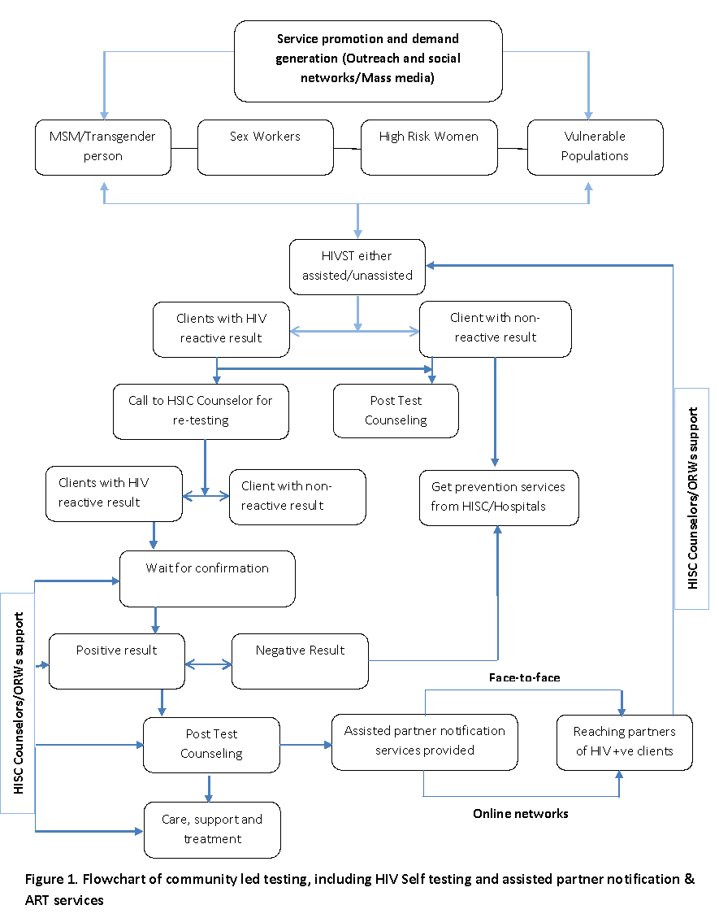

# Project Objectives

This demonstration project was conducted to:

* Assess the uptake and delivery models of HIV self-testing by men who have sex with men, transgender people, female sex workers, high-risk women and vulnerable population including choices made between assisted (supervised) and unassisted (unsupervised) testing.
* Monitor rates of confirmatory testing among those known to have a reactive result to the self-test.
* Uunderstand the key bottlenecks, acceptability of self-testing and preferences for self-testing implementation among men who have sex with men, transgender people, female sex workers, vulnerable population and their choices of delivery.

Primary Outcomes of the project were:

1. To recommend and establish an appropriate HIVST delivery model that is suitable for the Bhutan’s context which is conducive to key population.
2. The data on the proportion of self-testers who were tested for HIV for the first time is available.
3. The proportion of self-testers who choose unassisted/unsupervised versus assisted/supervised testing.
4. The proportion of self-testers known to have tested reactive and get a confirmatory test at HIV-testing service sites.
5. Description of participant’s views on the acceptability of self-testing and their preferences for how it is implemented.
6. Description of challenges and barriers to HIV self-testing.
7. Preferences for delivery points for HIVST kits.

# Research Design and Methods

STUDY DESCRIPTION-LOCATION

Bhutan Self Care Project is a cross-sectional, descriptive, mixed-methods study using both quantitative and qualitative data collection methods. This demonstration project adopted the methodological approaches and tools that were used in Linkage Nepal/FHI 360 Nepal, exploring the uptake and acceptability of HIV self-testing for men who have sex with men, male sex workers, and transgender people in Nepal and draft sentinel surveillance protocol.

**Quantitative**

Assisted/supervised and unassisted/unsupervised HIVST was offered within this project. The target populations of men who have sex with men, transgender people, female sex workers and high-risk women, and the vulnerable population were informed of the availability of self-testing by the peer outreach worker and HISC counselors during the outreach activity. All key populations were reached through peer-driven approaches and given an option to have either assisted/supervised, unassisted/unsupervised HIVST, or link to HISC for a rapid blood test for HIV, and the vulnerable population was reached by HISC counselors. All information related to the study participants was collected by peer outreach workers or designated HISC or Pride Bhutan counselors using standard forms. All were trained on HIVST, research protocol, quantitative and qualitative data collection methods. All clients agreeing to perform self-tests were provided the pre-test information. During registration at the clinic, the participant was provided a new standard unique identification code (UIC). Participants with confirmed HIV-positive results, as part of standard care, were to be linked with treatment and care unit.

Table 1: Proposed indicators for data collection

|  |  |  |  |
| --- | --- | --- | --- |
| Data collection tools | Person responsible | Data collection technique | Indicators |
| Client registration (Client Registration Form) | Peer Outreach Workers | -Online  -Face to face  -Other | # Number of clients contacted online, face to face, and others |
| HIVST client record form (Once consented for HIVST) | Peer Outreach Workers, HISC, Pride Bhutan | -Online  -Face-to-face  -Other | #The proportion of individuals who accepted HIVST  # The proportion of self-testers who were tested for HIV for the first time  #The proportion of self-testers who chose unassisted/ unsupervised versus assisted /supervised testing  # The proportion of self-testers known to have tested reactive and got a confirmatory test at HIV testing service sites |
| Study participant tracking sheet for unassisted/unsupervised HIVST | Peer Outreach Workers, HISC, PrideBhutan | -Online  -Face-to-face  -Other | The proportion of individuals who accepted HIVST and completed post-test interview  #Proportions of clients followed up |

**Qualitative Data**

FGD and Semi-Structured Interviews (SSIs) were used to understand perceptions and concerns about self-testing and various components of the implementation of the self-testing intervention. FGD was conducted among the peer outreach workers who reached to the clients, as they shared similar backgrounds and actively participate in the study implementation, and have in-depth views. SSIs were used to obtain information from a smaller number of people. These were participants with reactive and non-reactive results. Trained peer outreach workers interviewed those who have consented; about six to ten participants in each group or till the saturation of the information. FGD with peer outreach workers were conducted within two weeks of the completion of field implementation of the HIVST pilot and quantitative data collection to ensure that they had time to encounter confirmatory test cases. SSIs were conducted by a peer outreach worker using semi-structured questionnaires with men who have sex with men, transgender men and women, female sex workers and high-risk women groups. All measures for assuring confidentiality of the participants were ensured.

Table 2: Study framework

|  |  |  |  |  |
| --- | --- | --- | --- | --- |
| Data collection tools | Responsible person to administer tools | Target population | Data collection technique | Indicators |
| SSI questionnaire | Peer outreach workers (Trained) | Study participants with HIVST reactive and non-reactive results from different gender groups | One-to-one qualitative in-depth interview using key question guides | #Description of participant’s views on the acceptability of self-testing and their preferences for how it is implemented  # Description of challenges and barriers to HIVST |
| FGD guide | PI | Peer outreach workers | Conducting FGD and notes of the discussion recorded by a note taker |

# Operational definitions

* **Female sex workers:** Bhutanese or non-Bhutanese women aged 18 years and above who have provided sex for cash or kind in the last year.
* Men who have sex with men: Bhutanese or non-Bhutanese males aged 18 and above, who report anal or oral sex with another male in the past 12 months, regardless of their sexual orientation.
* **Transgender women and men:** Bhutanese or non-Bhutanese persons aged 18 and above who were assigned male sex at birth and now self-identify as “transgender” or “woman” or a gender other than male. Transgender women may or may not have undergone gender transition procedures (e.g., sex reassignment surgery, breast augmentation, facial implants), taken hormones, or dressed in women’s clothes, or present as female all the time. Transgender men follow a parallel definition, reversing the gender in the above definition for transgender women.
* High-risk women: Bhutanese or non-Bhutanese women age 18 years and above who work or visit hotspot environments where high-risk sexual behaviors are frequently initiated (e.g., commercial sex work, transactional sex, multiple and concurrent partnering, high partner turn-over, and sexual networking within and between key populations). We anticipate that high risk women will include female sex workers, but the definition does not require that the woman have engaged in commercial or transactional sex to be counted or participate in the sexual risk behavior surveys.
* Assisted HIVST: Refers to where CBT counselors and designated staff at HISCs will be trained to provide HIVST. Staff will provide key population members with an in-person demonstration before or during HIVST on how to perform the test and interpret the test result. This approach was used to support self-testers who consent to allow assisted services.
* Unassisted HIVST refers to when a client self-tests for HIV and uses an HIVST kit with instructions for use provided by the manufacturer/ national program without the help of a CBT counselor or staff designated at HISCs. Depending on the preferences of the HIVST, the peer outreach workers will deliver or decide the venue, time, and schedule of delivery or testing and referral systems and contact points.
* Vulnerable population included in this study are migrant workers, transport workers, uniformed personal, private business, civil servant, Farmer, Religious body, drug users, sero-discordant couples and students.

# Study setting

The project was conducted in five identified epidemiological zones of Thimphu-Paro, Phuntsholing (Chukha), Gelephu (Sarpang), Samdrup Jongkhar, Wangdi-Punakha. These are the areas where HISC is available and there is a concentration of key populations. The study was conducted in partnership with Pride Bhutan. For the vulnerable population, the study data were collected only in Thimphu.

# Target population

Target populations: high-risk women, female sex workers, transgender people, and men who have sex with men were part of the study. In addition, vulnerable population groups in Thimphu were also included. These included a diverse group which includes transport workers, migrant workers, monks, students, farmers, uniformed personal, civil servants, drug users, sero-discordant couples, private businesses.

INCLUSION CRITERIA

Inclusion criteria were as follows:

* Key population and vulnerable population who are aged 18 or older.
* Self-identified men who have sex with men, transgender men and women, female sex workersand high-risk women.

EXCLUSION CRITERIA

Individuals not eligible for the study were:

* Those known to be HIV positive, those receiving or had received any form of ARVs treatment in the last two months.
* Individuals with gum bleeding, and individuals with a known diagnosis of HBV, HCV, or HTLV (I/II).

# Sample size and recruitment process

As per the performance framework of the NACP has following testing targets for Year 1:

Table 3: The target sample size for each category of Key Population

|  |  |  |
| --- | --- | --- |
|  | The target for year 1 | The target for the demonstration project (6 months) |
| No. of men who have sex with men that have received an HIV test during the reporting period and know their results | 518 | 259 |
| No. of transgender people that have received an HIV test during the reporting period and know their results | 113 | 57 |
| No. of sex workers that have received an HIV test during the reporting period and know their results | 299 | 150 |
| No. of high-risk women that have received an HIV test during the reporting period and know their results | 343 | 171 |
| No. of clients, spouses, or intimate partners of the Index case (Annually about 50 cases are detected, about 25 cases every six months, each Index has an average of 1.8 partners) | 25 | 25 |
| Total testing target sample size over 6-months period of the demonstration project | | 657 (50% opt for HIVST =341 HIVST) |

Recruitment

Clients were contacted through various mechanisms such as online (Facebook, WhatsApp, WeChat, and other social media apps), dating apps, through telephonic contacts, and meeting in person. Peer-driven methods were used to initiate the contacts. Once the contacts and rapport were built, the peer outreach workers discussed the HIVST and initiated the informed consent process. A screening pre-assessment questionnaire was conducted to address eligibility criteria. Participants determined to be eligible based on this brief screening were contacted by email and phone to provide more information about the study. The peer outreach workers and counselors as well as social mobilizers directly contacted the clients through reaching out.

For the vulnerable groups, the counselors of the Thimphu HISC conducted testing camps in various locations, targeting diverse occupational groups in the general population considered to be high-risk or vulnerable.

Peer-driven recruitment (PDR) for key population

Peer-driven recruitment (PDR) method was used for population size estimate sampling and also proposed for sentinel surveillance. This method was found to be suitable for Bhutan. Hence, the same PDR recruitment process was selected for this study as well. The PDR method entails peer outreach workers contacting their networks to introduce the study. After the networks were contacted to participate, prospective participants were asked to refer other eligible key population members to the outreach worker or bring the outreach worker to venues where their peers can be found. Additional recruitment was done by visiting the venues to enroll eligible participants with the further snowballing methods at the venues or later by referral.

**Procedures**

* Initial contact: Once a peer outreach worker has approached or is referred to a prospective participant, an initial explanation of the study was provided. If the person consented to participate, the peer identified a place and time to ensure that the key population member is comfortable meeting in private.
* Eligibility and informed consent: The peer outreach worker conducted eligibility screening and obtained informed consent, and answered any questions the key population member had.
* Interview: If eligible and informed consent were provided, the peer outreach worker administered the standardized HIV risk and demographic questionnaire.
* HIV counseling and testing: Upon completing the questionnaire, the peer outreach worker provided pre-test information which included procedures on HIVST and a video to guide the key population participants. Then the participants were asked by the peer outreach worker if they would prefer to take the HIVST kit in an assisted/supervised or unassisted/unsupervised manner.
* Confirmatory testing and linkage to care: All reactive or indeterminate result were to be referred to the health care worker in HISCs. The peer outreach worker would explain the meaning of the preliminary result and the need for confirmatory testing. The peer outreach worker, if required, escorted the participant to the local HISC or agree upon a time and means to re-connect for follow-up.
* Incentives and further peer referral: Upon completion of their participation, the key population members were provided with nominal incentives for their time and transport. For their participation, each participant was given Nu 500 in form of mobile talk-time voucher. Participants were also encouraged to refer other potentially eligible acquaintances for the study by providing an incentive of Nu 200 worth of talk-time voucher for each recruit. Referrals were done in person (e.g., making introductions at venues) or by providing their friends with study contact information.

**Confidentiality, recording and linkages:**

The names and contact information were recorded and study identification (ID) numbers were assigned in a register, which was linked to the Unique Identification Code used for HIV reactive results. Although there were procedures set for any reactive cases, there was no reactive case for this demonstration project. The training was provided for all peer outreach workers on how to accompany the clients to HISC and provide confirmatory HIV tests following standard procedures as per the HIV testing guideline of the NACP, MoH. Their confirmed HIV test results were to be recorded in the standard register at the facility. Participants diagnosed HIV positive at the health facility were to be accompanied to the treatment center and provided standard care and support as per the national NACP guideline. All the information was uniquely recorded and confidential information was secured and was accessible only to researchers and designated health staff involved in this demonstration project and staff providing care and support. All the staff signed the information confidentiality, integrity, and code of conduct agreement with MOH.

**Recruitment for Qualitative Data collection**

Among men who have sex with men, transgender men and women and female sex workers who participated in HIVST were included in qualitative data collection irrespective of the test result. The purposive sampling method was used for SSIs with participants by the peer outreach workers. All vulnerable population data collection was conducted by HISC through outreach in various sites to cater to various population needs.

# Project Implementation Process

**Ethical Approval**

The study proposal was submitted to Research Ethics Board for Health (REBH) for review. The REBH accorded a waiver of ethical review and approval to conduct the demonstrations project as part of the program implementation process.

**National Stakeholders Meeting**

To advocate and garner support for the implementation of the HIVST, MOH conducted the national stakeholders meeting. During the meeting, the NACP appraised the protocol and the implementation process for the HIVST. The stakeholders included key implementing partners, Pride Bhutan, Lhak-Sam, Save the Children International, and Chithuen Phendhey Association (CPA).

**Training of the researchers**

The NACP conducted training for the researchers and peer outreach workers, HISC, and others involved in this pilot project. The training was focused on providing knowledge and skill on outreach activity, ethical standards, OraQuick SOPs, HIVST protocols, and data collection methods.

Data Management & Analysis

Peer outreach workers submitted all filled forms to the HISC counselor or Pride Bhutan, who cross-checked the completeness of the information. All incomplete information was refined in consultation with peer outreach workers. All data were entered into an excel form. The data were cleaned and checked for errors and missing values before analysis using SPSS. During data entry, any personal identifiers were removed and replaced by codes. Data coding and data entry was completed by the trained staff. All paper consent forms and the HIVST client register were kept in a locked cabinet at NACP for the study period and then later stored. The Principal Investigator (PI) validated and cross-checked all the data. Frequency tables were generated and data were checked for any discrepancies, outliers, duplications, and inconsistencies. Findings were verified with the primary data and corrected accordingly. All qualitative data were transcribed and translated by the research team. Transcripts were prepared from field notes. If it was in other local dialects, it was translated to English and entered as electronic files. The findings were triangulated with the quantitative findings under the pre-identified themes.

# Results & Findings

Descriptive analysis of the quantitative data was performed using SPSS. Data were analyzed under two broad groups; key populations and vulnerable populations. Frequencies, means, mode, and proportions were generated as per the required indicators.

The finding are divided into two sections. Section 1 ellaborates on the Key population and section 2 details on the vulnerable population.

# SECTION ONE: KEY POPULATION .

## A. DEMOGRAPHIC OF THE RESPONDENTS

### 

Of the 436 respondents interviewed, men who have sex with men constituted the highest number with 53.4% of the respondents followed by commercial sex workers (32.8 %) and transgender persons (13.8%).

**Table 4**: Category of respondents based on their sexual orientation.

|  |  |  |
| --- | --- | --- |
| **Category** | **Frequency** | **Percent** |
| Men who have sex with men | 233 | 53.4 |
| Commercial Sex Workers | 143 | 32.8 |
| Transgender persons | 60 | 13.8 |
| Total | 436 | 100.0 |

Thimphu and Paro had the maximum number of respondents with 75 % of the total, followed by Phuentsholing (9.4%), Punakha_Wangdiphodrang (6.9%), Gelephu (6%), and Samdrupjongkhar with 2.8% of the respondents.

**Table 5**: Distribution of respondents by Dzongkhag

|  |  |  |
| --- | --- | --- |
| **Districts** | **Frequency** | **Percent** |
| Gelephu | 26 | 6 |
| Phuntsholing | 41 | 9.4 |
| Punakha & Wangdiphodrang | 30 | 6.9 |
| Samdrupjongkhar | 12 | 2.8 |
| Thimphu & Paro | 327 | 75 |
| **Total** | **436** | **100** |

Except for Gasa, the participants came from all other 19 districts with the highest number of the participants being residents of Thimphu (8.9%) followed by Trashigang(7.8%), and Punakha (7.6%) ( Figure 2) .

**Figure 2**: Geographic distribution of key population respondents interviewed

A maximum number of the respondents were recruited through online outreach activity (57.3%), followed by venue-based (22%), membership contacts (19%), and HISC drop-in clients (1.5%). Only one respondent was referred by a friend (Figure 3).

**Figure 3**: Mode of research participants recruitment in percentage

In terms of academic qualification, 67.5% had less than class 12 level education and only 22% had university-level education ( Figure 4) .

|  |
| --- |
| **Figure 4**: Level of education attained by respondent |

The majority of the respondents (53.7%) were single (Never married) while 29.4% either lived together or married (figure 5).

**Figure 5**: Marital status of the respondents

The majority of the respondents were unemployed (33.3%), followed by private employees 15.8%, and 4.8% who worked in the entertainment sector (figure 6).

**Figure 6**: Occupation of key populations respondents.

### 

## B. GENDER & SEXULAITY

The majority of the respondents identified themselves as a man (52.8%) and woman (33.5%). 10.1% identified themselves as a transgender man and 3.4% identified as a transgender woman while only one participant identified as non-binary ( Figure 7).

Figure 7: Gender identity of key populations respondents

## C: SEXUAL RISK BEHAVIOR

The majority of the participants (51.4%) were straight (heterosexual), followed by gay 27.3% and bisexual 20.4% ( Figure 8).

**Figure 8:** Sexual orientation of the participants

In terms of sexual attractions, 64 % of the participants prefer sex with men only and 21.1% prefer sex with both men and women, and only 14.9% prefer sex with women only.

**Table 6**: Sexual behaviors of the respondents

|  |  |  |
| --- | --- | --- |
| **Sexual behaviors** | **Frequency** | **Percent** |
| Sex with both men and women | 92 | 21.1 |
| Sex with men only | 279 | 64 |
| Sex with women only | 65 | 14.9 |
| **Total** | **436** | **100** |

**Alcohol Use:**

About 70% of the respondents stated that they drink alcohol and the majority of the respondents (92.0%) of the respondents, ever had sex. 42.4 % of the respondents had sex under the influence of alcohol, and 22% of the respondents who had sex under the influence of alcohol did not use condoms.

**Table 7:** Alcohol consumption as a risk factor for sexual behaviors

|  |  |  |  |
| --- | --- | --- | --- |
| **Alcohol consumption** | **Responses** | **Frequency** | **Percent** |
| No | 133 | 30.5 |
| Yes | 303 | 69.5 |
| Total | 436 | 100 |
| **Sex under the influence of alcohol** | Missing | 32 | 7.3 |
| Don't know | 1 | 0.2 |
| No | 218 | 50 |
| Yes | 185 | 42.4 |
| Total | 436 | 100 |

Of the respondents, 92% had sexual contact with their partners while 7.8% of the respondents claimed to have had no intercourse. The majority (18.6%) of the respondent had their first sexual intercourse at the age of 18 years. However, a significant percentage (17.3%) of respondents had sexual intercourse before the age of 15 ( Figure 9).

**Figure 9**: Age at first sexual intercourse among key population respondents

The majority of the respondents (66.7%) had less than 3 partners in the last 30 days with 18 respondents stating that they have more than 3 sexual partners ( Figure 10) .

**Figure 10**: number of sexual partners in the last 30 days

## D: HIV TESTING AND PREVENTION

Among the key populations, 91% (212/233) of men who have sex with men, 73.4% (105/143) sex workers, 81.7% (49/60) transgender men and women were aware of the places to get tested for HIV. The rest of the key population respondents did not know about the location of testing facilities available for HIV testing. Of the key population respondents, 60.5% of men who have sex with men, 74.1% sex workers, and 75% of transgender men and women were tested for HIV. Of those who got tested, 69.1% of (161/233) men who have sex with men availed testing service at the referral hospital, 15.5% (36/233) at the district hospital, and 5.2% (12/233) at Basic Health Units, while 2.6% (6/233) got tested at private diagnostic clinics. Few of them got tested in Lungtenphug Military Hospital and also across the border in Jaigaon, India. Of the sex workers who got tested, 43.4% (62/143) availed the service at referral hospitals, 4.2% (6/143) at district hospitals, and 46.2(66/143) at HISC, while 2.8% got tested at private diagnostics. 53.3% (32/60) of transgender men and women were tested at the referral hospitals, 1.7% at the district hospitals, and 68.3% at HISC. Figures 11 and figure 12 illustrate the testing facilities accessed by different key populations.

Among the key populations, 37.8% of the men who have sex with men, 33.65% of the sex workers, and 38.3% of the transgender men and women had also tested for other sexually transmitted diseases and a high proportion of genital ulcers and discharges were found among them .

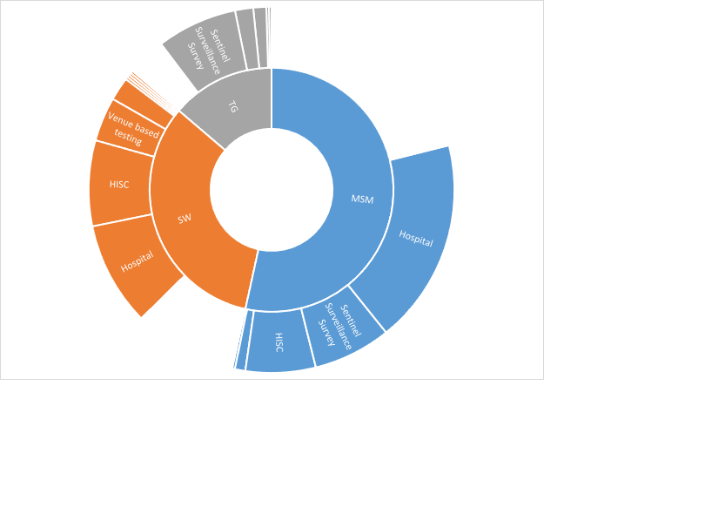

**Figure 11**: Testing site of those who got tested by different groups of the key populations.

**Figure 12:** Types of tests used by different key population groups

The majority of the respondents (24%) were revealed to have tested for HIV (Figure 13) within the previous 12 months. However, 15% of men who have sex with men, 24.9% of sex workers, and 6.6% of transgender people have last tested 12-24 months ago. 60% of the men who have sex with men, 65.7% of sex workers, and 63.3% of transgender people obtained the laboratory test results after testing to know their status of HIV infection.

**Figure 13**: Time duration of HIV testing among key population groups.

The proportion of the different key population groups attending an HIV educational event in the last year is given in Figure 14. Of the key populations, 8% of men who have sex with men, 18% of sex workers, and 17% of transgender men and women had attended an educational program. They mostly attended events and conferences organized by hospitals, national programs and schools. Few attended the Training of Trainers (ToT) program on HIV. Of the total respondents of key populations, 31% of men who have sex with men, 35% of sex workers and 57% of transgender men and women revealed that health care workers reached out to them to talk on HIV prevention and control in the last twelve months.

**Figure 14:** Numbers of key population attending HIV educational program

## E: STIGMA & DISCRIMINATION

The majority of the men who have sex with men (89%) and sex workers (99%) revealed that they could not share their gender identity and sexual orientation with their family and friends. Similarly, 22% of the transgender were not able to do the same with their family, friends, and strangers. Men who have sex with men (4%), transgender (2%), and sex workers (7%) also reported stigmatization by health workers while accessing health services.

## F: MEMBERSHIP OF NGO

11% men who have sex with men, 18% of sex workers, and 73% of the transgender men and women were the members of Pride Bhutan. Only 0.4% of men who have sex with men were members of Lhaksam while 0.4% men who have sex with men, 24% sex workers, and 20% transgender people were members of the Red Purse Network.

13% of the men who have sex with men and 22% of sex workers were willing to join Pride Bhutan, while only 8% of men who have sex with men and 15% of sex workers were willing to join Lhaksam. A similar trend was observed for Red Purse Network. 54% of the men who have sex with men, 6% of sex workers, and 3% of transgender men and women did not become members as they wanted to maintain strict privacy, while 32% of sex workers and 6% of men who have sex with men were not aware of the existence of such NGOs in the country.

## G: HIV SELF TESTING UPTAKE

The majority of the respondents (94.4% men who have sex with men, 99.3% sex workers) were receptive to be contacted for delivery of HIVST and follow-up on the result of a test done using HIVST. More than 94% of respondents of all groups of key population were also receptive to them being contacted for health education programs.

## H. QUALITATIVE FINDINGS:

A total of 18 in-depth interviews were conducted. Except for Gasa and Lhuentse, there was at least one participant from all districts representing a diverse range of participants. The participants’ ages ranged from 18 minimum to a maximum of 30 years old with SD +-2.95.

Except for 4 participants who had university degree qualifications, the rest of the 14 participants either had a higher secondary level or middle secondary level education. On the marital status, 16 participants were single and 2 divorced. In terms of occupation of the participants, 2 were business persons, 2 were from NGOs, 2 were private employees, 4 were students, and 8 were unemployed.

### Gender & Sexual Identity

The majority (50%) of participants identified themselves as men (Table 8). In terms of sexual identity, 67.7 % were straight (Heterosexual). Among the participants, 11 were men who have sex with men, 3 were sex workers and 4 were transgender people.

**Table 8**: Gender identity (N=18)

|  |  |  |
| --- | --- | --- |
| **ender Identity** | **Frequency** | **Percent** |
| Man | 9 | 50.0 |
| Nonbinary | 2 | 11.1 |
| Transgender men | 1 | 5.6 |
| Transgender women | 3 | 16.7 |
| Woman | 3 | 16.7 |

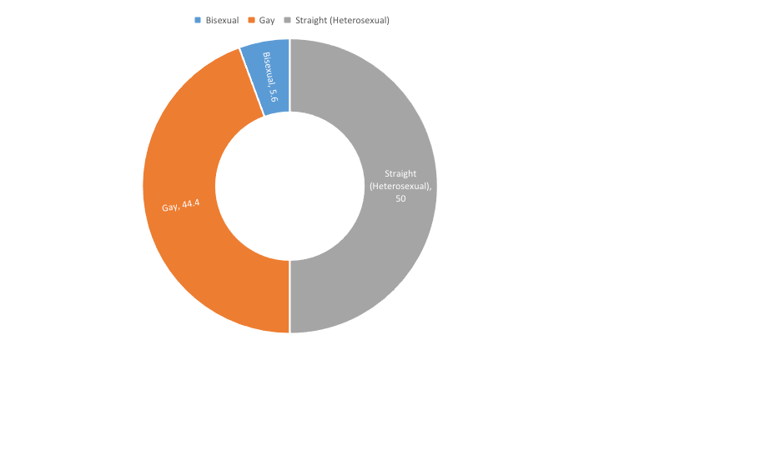

**Figure 15**: Sexual orientation of the respondents (%, N=18).

### Mode of recruitment

Of the total participants, 11 were recruited through the membership network and seven were recruited through outreach activity.

### Health problems

About 10 participants had some minor health problems which ranged from cough and cold to piles and migraine.

### Problems associated with availing health services for key population

A man who has sex with men participant described the problems faced while availing health services from healthcare centers as evidenced from following statements:

“*.. Firstly, there are no Key Population-oriented services. For instance, there are no gender experts to give counseling for gay people. For trans, there is no hormonal replacement therapy and things like that. So, the existence of services itself is a problem. Secondly, it’s not that the health service provider is an issue, it’s the environment that is an issue. For instance, when you go to hospital and you are very visible, for instance when it comes to me, I am very flamboyant, people tend to notice and stigmatize. It is not the service providers who are doing it but it is the other people who are availing the services, making the environment hard to avail the services*.” Participant THMSM27.

One of the men who have sex with men participants also stated:

“I *am not sure but I feel there is favoritism. The token system is better but when there is someone who doesn’t know anyone at the hospital takes time to get health services.”* THMSM3*.*

A transgender woman participant stated*,*

“So *when it comes to medical services if you are bold enough to go there and say that I am a transgender and I am having this problem then it’s not a problem. But if you are timid and kind for an introverted person then you cannot go there and say I am a transgender and I am going through this kind of thing. So, when it comes to the health issues or health services, I just didn’t face any problem because I think I am bold enough to go there and tell them that I am transgender and I am having these problems could you help me with that. So, I didn’t face any discrimination or anything like that. Yes, that thing (stigma) keeps revolving around my head but when I have to do it practically, I just somehow manage to bind myself with the confidence so it’s not a very big issue that I have faced or facing*”.

A gay participant stated,

“*Regarding existing health services, is that system itself is a problem. Currently, there are no gay people giving services, for instance, no gay counseling. There are no gender experts to do counseling. There is no… and it is not the problem of health service providers but its environmental problem. When I go to the hospital all can see me and stigmatize and make the environment conducive*”. THMSM27

Most participants stated that they usually go to a hospital whenever they get sick. However, if it is a minor ailment, they visit the pharmacies. All the participants also had HIV tested, mostly at HISC.

In terms of challenges faced by key populations, access to healthcare services, social stigma, and not availing of testing services are the main challenges.

One of the men who have sex with men participants stated,

“…*the main challenges for me and my friends face are that there aren’t many centers that we can access when it comes to HIV or we are not aware of centers. So, if we are made more aware of where they are and how we can access them. Maybe it will much better. Maybe we will be able to access them a bit more. And even if we have bit more problems. I don’t think there aren’t many discriminations against HIV these days, it is much reduced. So just the availability of where these centers are and the information on how we can approach them is the main challenge for me*”.

To resolve these challenges, most participants recommended the need for enhanced advocacy.

One men who have sex with men participant stated that,

*“First we need a high level of advocacy but we need that on a large scale because like I said there aren’t many services and to have services there needs to be policy in place there need to be experts who can deliver the services adequately. So first there needs to be a policy then secondly sensitization and thirdly infrastructure itself. For HIV, a VST unit which is separate from JDWNRH now provides HIV services much like that even for the key population if the services can be provided at one place or location. Maybe they don’t need a separate infrastructure but an expert who is in a very ideal environment for example clubbed with HISC, having a separate cabin itself will make a difference, I think.*”

### Initial feeling before availing the HIVST service

Many participants (50%) experienced some degree of feeling scared, nervous and fearful before the HIV self-test was conducted. Only one (5.5%) participant stated a feeling of excitement and the rest (44.4%) of the participants said that they felt normal. The feeling of uneasiness or nervousness was more common in participants who have not done the test before ( %) and most of the participants, who have done the test earlier ( %) seemed more normal while waiting for the result.

**Table 9**: Emotional states of the participants availing HIVST service (N=18)

|  |  |  |  |  |  |
| --- | --- | --- | --- | --- | --- |
| **Emotional state** | **Scared** | **Nervous** | **Fearful** | **Excited** | **Normal** |
| Before testing | 4 | 4 | 1 | 1 | 8 |
| During Testing | 1 | 8 |  |  | 9 |
|  |  |  |  |  |  |
| **Emotions after test** | **Happy** | **Relaxed** | **Relieved** | **Normal** |  |
| Number | 4 | 4 | 4 | 6 |  |
|  |  |  |  |  |  |
| **Type of Test done** | **Assisted** | **Unassisted** | **Blood Test** |  |  |
|  | 15 | 1 | 2 |  |  |

### Understandability of the information

Except for two participants, who stated they understood “little bit”, all the participants said that they understood the pre-test information, post-test counseling, and test instructions.

“Yes*. If it is available in pharmacies, when we have doubt, we can go there easily and buy it. If someone goes on tour and has a physical relationship, one can buy it from a pharmacy and buy it for testing*” as stated by a 23-year-old man who has sex with men from Gelephu.”

“*I understood about the test kit. Its advantages, drawbacks, and limitations. How to use it, window periods and also what to do after the test depending on the results*.”

### Decision to participate in the study

Most of the participants stated that they participated in a study to know their status of HIV infection and also with the thought that HIVST would be beneficial to the community.

*“Since self-testing is like first time which is relatively new. Moreover, if we think well, one can get tested by oneself and there is more privacy. If I know about this, others who I might know are shy and are not able to approach for help and share it with me. At least if I give knowledge on self-testing kit, I could help them.*”

” *Ah…I participated in this, I…hmm…I was very curious as to know my own HIV status even though I have never done anything before I was very curious how it would happen. So that is why I participated in this. Also, I was very curious about how it was done, you know. I never thought our saliva could contain or could clarify our HIV status. So, I wanted to learn how it works. And at first, I chose self-test because it seemed a bit more comfortable since I am doing it myself. And there are no interruption inclusions. The second time I did a blood test, I think apart from saliva, a blood test is a bit clearer and more confident where we can find our test. That is why the second time I did was a blood test and it was better.*”

One sex worker participant stated,

“*To be honest, I usually drink and use drugs which is risky for us. When we stay with partners in such a state, some of them do not use a condom and some of them might be lying even if they say they used condoms. Also, there are chances of bursting condoms and spreading STIs while sharing inner wears and toilets. Thus, I thought that if I did my test, I would be clear about myself. Moreover, even if I test positive even if it’s for gonorrhea or syphilis there are medications before it gets too late. If we are careless, it is us who would suffer in the end. On the other hand, my friend encouraged me and I also thought of some positive impacts.*”

### Opting for HVST by friends and peers

Except for two neutral participants, all said that their friends would opt for the HIVST test as it is easy to use, one does not have to go to the hospital, and protects their privacy but all agreed that it should be made accessible from non-conventional distribution points. It should be made available from HISC, Pride Bhutan, medical shops, entertainment venues, and also in schools. In addition, the availability of the test as an option to conventional hospital-based screening test needs to be advocated well.

*“There are health clubs in school and they give sex education. I would suggest that some test kits be kept in schools. And even in drawings and clubs. It should be made easily accessible*”, as stated by the 23-year-old gay participant.

“*Of course, they will but first, they have to be advocated and informed well about this because these things are coming. Like when a pregnancy test came for the first time many weren’t aware of it. So first is to publicize it. If its publicized everyone will avail themselves of it. When we talk about such diseases, they get stigmatization to the kit will be availed. They would get it from the pharmacy.*”

### General opinions of respondents

Most participants have positive opinions about HIVST.

*“.. I don’t see much risk because the people who are doing this test, I think there is a benefit for the client and also for the one who is researching on this. Because in both ways they will get the result of how what their condition is and what their status is. So, I think HIVST is very beneficial in society because it is kind of like advocating on HIV in a very, you know, severe manner. Because we will be able to learn what is happening, how it is being done. So, everyone will be common to this. So, everyone will understand how it is being done so I think it is a kind of advocacy and a very beneficial one.*”

### Improving Services for Key Populations

*“I will recommend being an RPN member. We don’t know when we will be exposed to HIV. So, whenever we have sex, we have to get tested. Some say they forgot the condom so when one needs money, they do it. No matter what, I would suggest they not have sex without protection. Some suggest we take I-pill because they only think about pregnancy. They say they don’t have the disease; it is fine unless you are pregnant. They also promise us with a large amount of money and also additional money needs it to be. So, what we think is, unless we get a huge amount of money, okay. Some do it. What I would suggest is not to engage in unsafe sex.”*

Other participants stated:

*“Regarding the HIV self-test service to men who have sex with men, transgender people, high risk women, and female sex workers ah can be improved by like providing all the contraceptives to the public places and then in the medical shops. And then the HIV self-testing service to be improved by providing in medical shops whereby people can come there for medical issues so they can be like educated there well. They can take it from there. And then I would say more probably public places where lots of people gather and they can like take it free from there.”*

# **SECTION TWO: VULNERABLE POPULATION**

### 

## A. DEMOGRAPHIC OF THE RESPONDENTS

Out of the total 447 tests conducted, the maximum number of tests were conducted among migrant workers (20.6% ) followed by transport workers ( 20.6%)

**Figure 16:** No of participants from various vulnerable groups enrolled .

## B. GENDER & SEXULAITY

**Figure 17:** Gender identity of vulnerable populationrespondents

## C: SEXUAL RISK BEHAVIOR

A total number of 447 individuals under the vulnerable groups were interviewed and of which 324 (73%) identified themselves as male and 120 (26.85%) as female. Only one person was identified to be transgender. The majority of the participants were migrant workers and transport personnel (40.04%). 30% of the participants were comprised of civil servants, businessmen/women, and uniformed personnel. All the respondents under the vulnerable group identified themselves as heterosexual.

**Figure 18**: Gender identity of the respondents

Almost 40% of the participants consumed alcohol. Among these, 21% were involved in sexual intercourse under the influence of alcohol (Table 10). Of these, 64.8% (264) did not use condoms or they cannot recollect using them while indulging in sexual intercourse under intoxication.

**Table 10**: Alcohol consumption and sexual behavior under the influence of alcohol

|  |  |  |  |
| --- | --- | --- | --- |
| **Alcohol consumption** | **Responses** | **Frequency** | **Percent** |
| No | 271 | 61.73 |
| Yes | 168 | 38.27 |
| Total | 439 |  |
| **Sex under the influence of alcohol** |  | 32 | 7.27 |
| Don’t know | 121 | 27.50 |
| No | 225 | 51.14 |
| Yes | 94 | 21.36 |
| **Use of condoms during sex under the influence of alcohol** | Yes | 93 | 35.2 |
| No | 151 | 57.2 |
| Can't remember | 20 | 7.6 |

The majority of the respondents had their first sexual intercourse between the age of 15 to 23. Participants who had first sex before the age of 15 years constituted 3.7% (16) while 31.9% (137) abstained from revealing it. Sixteen participants’ age information was missing (Figure 19).

**Figure 19:** Age at first sexual encounter among vulnerable population respondents (N-430)

In the last 30 days, 83% of the participants had no or just one sexual partner and 8% had two, while 8.8% had more than three sexual partners (figure 20). Drug users and transport personnel had significantly higher numbers of sexual partners in the last 30 days.

**Figure 20:** Participants with multiple sexual partners in the last 30 days.

## D: HIV TESTING AND PREVENTION

Of the total vulnerable population respondents, 43% (179/412) were not aware of the location and availability of the HIV testing facility. Only 55% (244/447) of vulnerable populations availed testing services to know their HIV status. 42% (75/179) of the respondents who tested availed service from HISC, while another 42% (75/179) of the respondents availed it from hospitals. The remaining respondents availed themselves of the testing service through the outreach clinics. All those who availed of HIV testing had done blood testing from the services centers. At the time of undertaking this study, none of the respondents undertook oral rapid testing. 46% (113/248) of the testing of the respondents, who had undergone testing, were undertaken more than 2 years ago and 36% (88/248) had tested within one year, while 19% undertook the testing between 12 to 23 months ago. Although the majority ( %) of the vulnerable population who availed testing services obtained their test results, a significant number of them ( %) did not know the status of their test result.

Only 12% of the vulnerable population respondents attended various HIV education programs conducted by the Ministry of Health in the last 12 months. Only 2.3 % of the respondents have talked to healthcare workers regarding HIV prevention and control. 2.8% (36/437) of the respondents were tested for STI in the last 12 months. None claimed to have suffered from any form of genital ulcers, while 1% (6/437) suffered from genital discharge.

## E: STIGMA & DISCRIMINATION

## 

Of the 447 vulnerable population respondents, nearly all (445/447) except 2 shared their gender identity or sexual orientation with their family members.

## F: MEMBERSHIP OF NGO

0.2% (1/447) of the respondent were members of the Pride Bhutan and Lhaksam. None were members of Red Purse Network or other NGOs involved in HIV control and prevention. However, 99% of the respondent were willing to join as a member of any of these NGOs.

## G: HIV SELF TESTING UPTAKE

All of the respondents preferred to be contacted for delivery of HIVST to them for self-testing and follow-up on test results and HIV education program. 98.6% (432/438) of respondents agreed to be part of the HIVST acceptability or uptake program while the rest of the respondents were either hesitant or unwilling to participate.

Among the respondents, 70.7% preferred to have Assisted Self Testing method, and 22.6% preferred to have Unassisted Self Testing while the remaining preferred the traditional center-based blood test at HISCs.

## H. QUALITATIVE FINDINGS

### Demographics of Participants

Among the 45 participants interviewed, only 7 respondents (15.6%) had university degrees and the rest had either no education or less than higher secondary education. Maximum (73.3 %) of the respondents were married and 24.4% were never married. In terms of occupation, the maximum (28.9%) was private employees followed by government employees (24.4%). All the participants were heterosexual/straight. The participants’ ages ranged from 20 years old to 61 years old with a mean age of 34.5 and standard deviation of 9.3 years.

**Figure 21**: Proportion of respondents’ level of education (N=47)

**Figure 22**: Occupation of respondents

### Health issues

Among the participants, 28 did not have any health issues and the remaining (17) had some health problems ranging from a toothache, migraine to hypertension. 1 also reported suffering from STI.

### Access to health services

In terms of access to health services, there was a mixed response particularly towards the health facility (see table below).

**Table 11**: Sentiments of respondents

|  |  |  |  |
| --- | --- | --- | --- |
| **Sentiments** | **Negative** | **Positive** | **Neutral** |
| **Response** | 20 | 15 | 10 |

Many participants highlighted problems in accessing services at the National Referral Hospital. One of the participants said,

*“I have noticed and observed that the service provided at JDWNRH is unfair, bias and favoritism to the one they know. The service providers are not treating the public equally. If you know some staff from JDWNRH, your work can be done in a day if not you have to wait till you get an appointment.*”

Another highlighted:

*“If you don’t have any friends or family working in Hospital that there is the problem of not getting an appointment or you will take weeks to get full treatment. While visiting JDWNRH there is a problem from moment you enter the hospital, we don’t get token, if we got token then we are not able to see doctor, by 3 pm hospital is closed and we have to go back next day.*”

*“I don’t visit JDWNRH; rather I would go to the private health center for treatment if you don’t have anyone who knew you at JDWNRH you will take a few days to get treatment.”*

*“Many of people complain of a waiting period of 5-6 hours to check by a doctor and 3-4 hours to collect medicine.”*

*“I don’t think any major problems faced as of now in terms of accessing the health service, whenever we need to seek health facility, we can easily assessable.”*

*“Bhutan is blessed by Zhabdrung Rinpoche and our Kings, and we have free medical services without any problem for peoples like us.”*

In terms of place, the health facilities that the participants visit when they are ill are shown below:

**Table 12:** proportion of respondents visiting different healthcare centers

|  |  |  |  |  |  |
| --- | --- | --- | --- | --- | --- |
|  | **JDWNRH** | **HOSPITAL** | **BHU** | **PRIVATE** | **Others** |
| **Number of respondents** | 20 | 12 | 7 | 5 | 1 |

### HIV test among participants done in the past

The proportion of the respondents who have tested for HIV is given in the table below.

**Table 13**: HIV testing among the respondents.

|  |  |  |  |
| --- | --- | --- | --- |
|  | **Yes** | **No** | **Total** |
| **HIV test done** | 31 | 14 | 45 |

Some statements from those participants who have never done HIV test before:

“Never*, this is doing my first time and this testing was done by the health team.”*

A few statements from those who have done an HIV test before are as follows:

“*Yes, I have done many times at the hospital, HISC during endoscopy.”*

*“Yes, I had done many times here at JDWNRH and HISC.*”

*“Yes, here at Tango when the health team was visiting here for a health checkup, I did this HIV Testing. I didn’t face any challenges since the health team was coming here at the doorstep.”*

*“I have done once while a group of health team visited at our construction site and I didn’t face any difficulty in getting the test done.*”

“*Yes, I am doing every six months at HISC, so far no challenges in getting the tests done, HISC staff are so friendly, helpful and professional.”*

“*Yes, we have done last year at Chamgang central jail*.”

Some challenges in accessing condoms as one participant stated:

“*Especially during the night after-a party, when we need a condom, all shops are closed and we landed up taking risk while having sex, when we go to hospital emergency, they don’t give condom.”*

Another participant said:

“*Most of the people don’t know where to go and get the test, I know many people’s who don’t know where is HISC in Thimphu suited and why HISC is set up.”*

*“HIV itself is very dangerous and it is believed as very dirty disease, there are challenges to say about the name of diseases.”*

“*Discrimination and fear of peoples talking about HIV/AID prevention services and HIV testing.”*

“*Since being monks, we are not able to visit hospitals and request HIV testing.*”

*“Fear of testing positive, if tested positive then all other taxi driver friends will talk about me and my family*”.

On stigmatization of HISC, one respondent said:

“*As you all know that talking about sex is the main challenge in our society, when we are visiting hospital and HICS peoples thinks that we are also infected with HIV. Because of stigma, we have to avail HIV services like hiding and seek game.*”

Confidentiality:

“At *hospital and health center they don’t feel save as they don’t maintain confidentiality, as most of them don’t feel save while visiting hospital.*”

### Suggestions to resolve the challenges

### Many participants suggested some solutions to the challenges and improving the services of HIV/AIDS services.

“*Everyone should be treated equally not based on their status, they should never bias among the public, everyone needs same treatment and case. Open more HISC and testing center in different location and awareness.”*

“*If you go to hospital and HISC for HIV-related service everyone will look at you and think you are one of the positive.”*

“*I request to supply condoms to party hall owners.*”

“*Awareness on HIV and related STI disease every time after 10 pm on BBS channel like in other countries.*”

“*Open more HISC to every Dzongkhag so that many peoples will come for the test.*”

### Reasons for participating in the demonstration project

Most of the participants stated that they participated in the study to know their HIV status and also since the test was easy, simple, and one don’t require drawing blood. Some said that they participated due to curiosity as the test is new in Bhutan. Following statements are made during interviews:

“*HIVST is an easy and simple method of testing with no pain and we get instant results too.”*

“*I have never done HIV testing so I wanted to try with oral test with blood from my body.*”

“*I was requested to take part by the madam, I was afraid of needle and I choose with.*”

“*I am interested to take part and I choose oral HIVST because if we chose blood, I need to go to HISC.*”

“*I volunteered to do the test when I heard we can test HIV from the mouth, so I choose the oral HIVST.”*

*“Since I have not done HIV test before I volunteered myself, I have chosen to do it with the oral test as it is very convent and no need to visit the hospital and also no need to wait for the result.*”

“*It has been a very long duration that I haven’t done an HIV test, so I decided to HIVST as I don’t have time to visit HISC for blood, so choose HIVST.*”

*“I was approached by a health worker from HISC to take part as we know each other’s, so I decided to choose oral swab test as it is new and it does not require to draw blood from my body.”*

*“I was very excited to do this test since I find it very easy and comfortable and more ever the test result is instant.”*

*“I had chosen oral swab test because I found it is very interesting and first time here in Bhutan.”*

*“It is good to do HIV test and update about the status of self and chose this type of test because it is very simple and no need to go to Hospital for giving a blood sample.”*

*“I volunteered myself as I wanted to do HIV testing with new oral HIVST, we never know that we are infected, we can only know by testing.”*

*“This self-testing is very easy and I find very comfortable to do this test where we can do even at home in future if in case it is available and what I felt more comfortable is that we can directly contact the health person as per our test result.”*

*“This is one of the great opportunities for us to do a test here at our place, if we visit Hospital for testing, we might take one full day to choose to try with oral HIV testing.”*

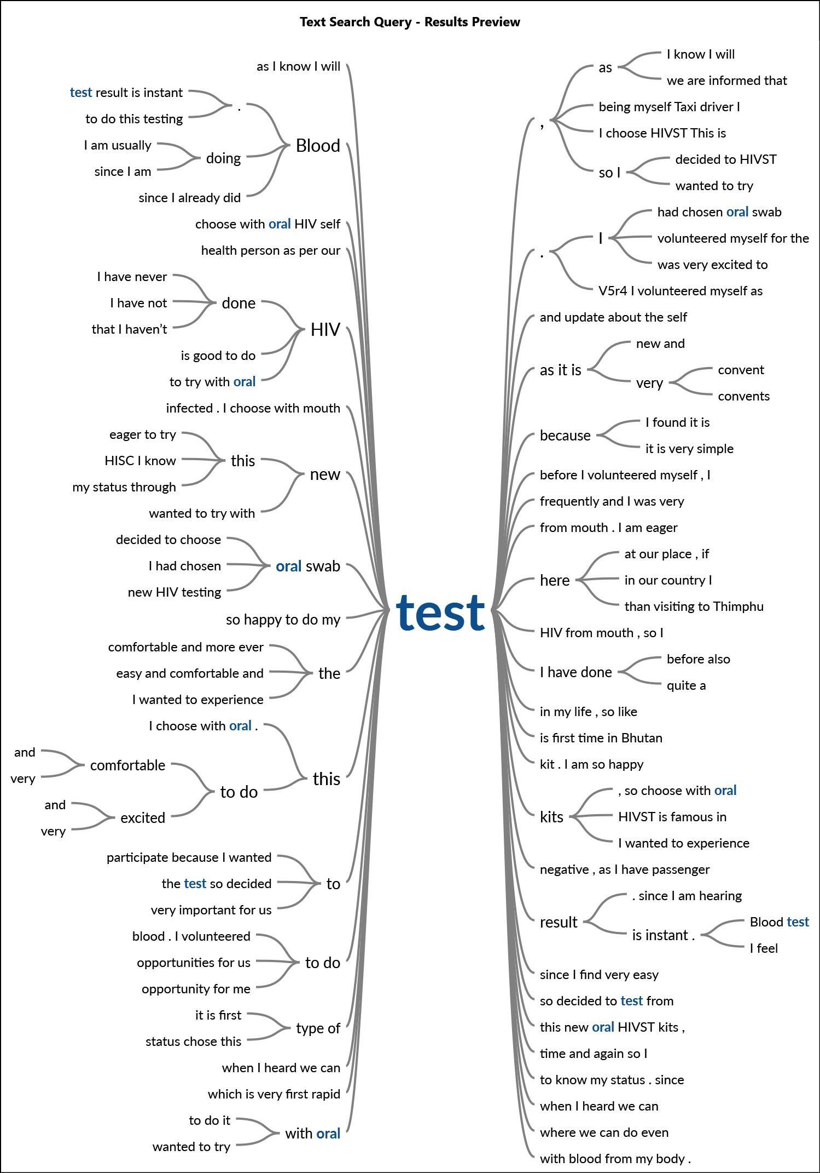

**Figure 23:** Word tree for “Reasons for choosing HIVST”

### Initial feeling

Nervousness, worry, and excitement were some of the feelings that participants expressed. Most of them stated that they feel nervous and worried to see the result.

“I was a bit worried but also excited about my test result since I never do any kind of testing on HIV.”

“To be frank I am worried because we don’t know how our partner is doing when we are not around.”

A serodiscordant couple stated,

“Instead of nervous, anxiety, fearful and all, I was more eager to do this test and to know my result since my husband was already living with these diseases.”

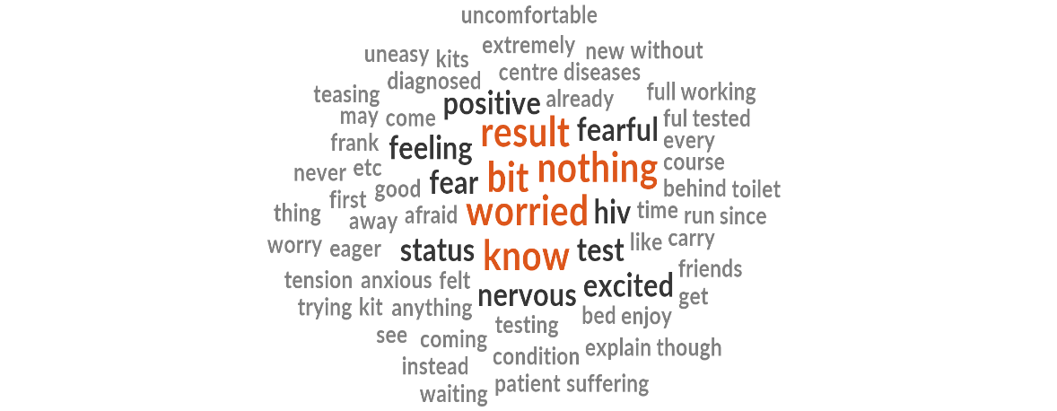

**Figure 24**: Feeling expressed by respondents

Most of the participants expressed the feeling of joy, happiness, and excitement after they found their status by the test result.

*“Happy and I feel I am clean and free from virus,”* was one of the statements from one participant.

### Testing Method

Except for three participants, all did assisted testing. Most stated that it was their first time and sought help from the health staff.

“*Being the first time, I choose to in front of health staff with help from one lady from HISC.*”

“*I did this test with supervised since I thought that I can learn more and so that in future I can perform myself, even I can teach my friends who are not aware.*”

“*I did it myself as I am a bit worried, I have sent a picture of my test result to one of the madams*”

### Understanding of Instructions

All the participants stated that they understood the information provided.

“*This test is very easy and comfortable where we can do even at home but for the confirmation, we have to do another test if the result comes with reactive. Before performing this test, we should not take anything for 20 to 30 minutes. The test result is instant*”.

### Experience of testing

Most of the participants stated that they were nervous before the test and during the test. But when the results were seen, it was a sigh of relief.

“*Before and during testing it bit nervous as this is new, its very simple everything is explained before we are given test kits and instruction leaflet inside the packet is very simple and clear*.”

### Willingness to avail HIVST in future

All the participants said that they would be willing to do HIVST. Some cited that it is easy and can be made accessible without having to go to the health facility. They also mentioned that it should be made easily available in pharmacies, HISCs, and even in the barber shops and small shops.

“*Yes, I learned all steps of testing, I would suggest to get HIVST from pharmacy shop and request you all to keep like a condom in hotels and bars*”

“*Yes, I can perform this HIVST test if it can be available here at our workplace too besides above mention places so that everyone gets tested*”

“*Yes, I prefer where ever there is easily assailable to do this test because this is more comfortable and easily performed by our self*”

*“I found very easy and informative information. The test result will be kept confidential and this is an instant result*”

“*This test is too confident and more comfortable and if this can be available above mention place and also another entertainment place like Drayang, karaoke, etc*”

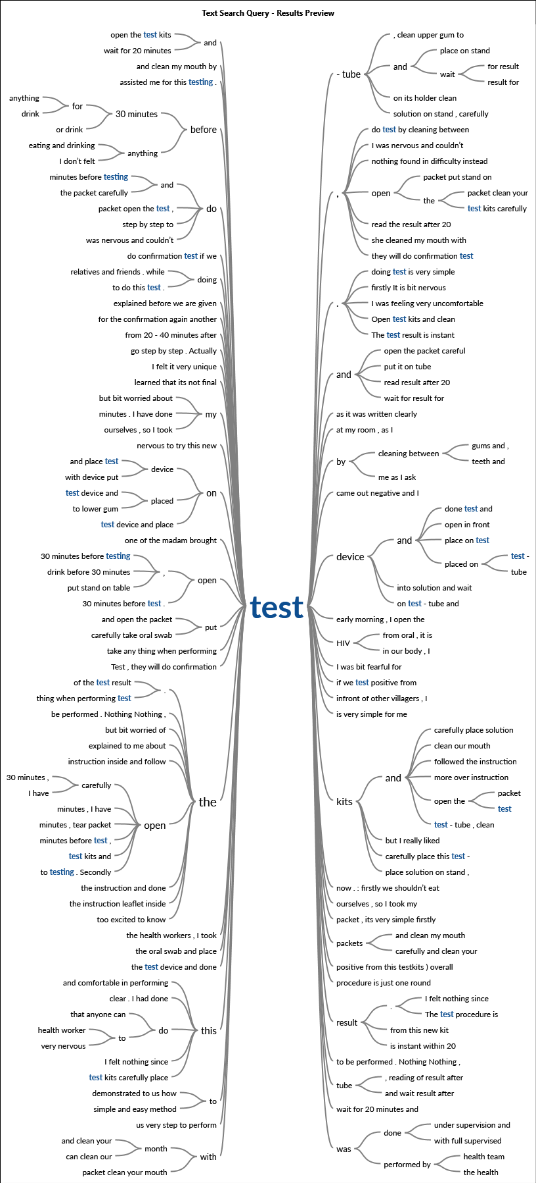

**Figure 25:** Word tree for HIVST

### Participation of friends/peers in the testing

36 out of 45 interviews conducted stated that their peers or friends would prefer to have HIVST. Three participants said they don’t know and six participants said they would prefer blood tests rather than HIVST. The reasons for preferring blood tests were merely as the HIVST is new and participants don’t trust the results.

“*I have told my friends about new HIV testing but many of my friends like to do a blood test, as they said they trust blood tests and I am also planning to go for one blood test for HIV*” .

“*No, most of the girlfriends say they would like to do a blood test as they said they don’t trust oral swab test*”.

“*Most of my friends they said they prefer blood test than HIVST because from the blood we could see detect three types of disease whereas HIVST can detect only HIV but few of them suggest HIVST is better*”

The reasons for opting for HIVST are easy, accessible, and maintaining confidentiality as evidenced from following statements .

“*I think many of my friends will do HIVST since it is very simple and we can do it anywhere*”

“*I would say 100% all of my friends will be preferred to have this test because most of my friends fear for needle while drawing blood at the hospital*”

Most participants felt that HIVST is generally useful for people.

“*I think this HIVST will be liked by all peoples as it is easy and simple for testing. With every advantage, there is a risk, like not reporting to HISC or Hospital if found positive during HIVST*”.

# Discussions

The Population Size Estimate and sentinel surveillance study[9] points towards strengthening case detection with a focus on key populations and vulnerable populations. To this front, HIVST, considering its convenience, easy to use and reliable test can be the tool for reaching out to the population that is particularly hidden. The study also recommended as an outcome of the sentinel surveillance. Despite the lockdown and COVID-19 restriction, the HIVST demonstration project was conducted successfully and this would enable the National HIV, AIDS and STIs Control Program under the Ministry of Health to expand and expedite the implementation of self-test. HIVST was also found feasible in many countries within the region and globally and successfully implemented. As the country gear towards the elimination of HIV, it is important to close the detection gap.

Despite reaching a large number of key and vulnerable populations, the study did not produce any reactive results. This could be either due to; 1) the survey failed to reach the intended target, or failed to penetrate to the population who have never been tested and who are of very high risk; or 2) there are no more cases within the target population and detection gap estimates may be false or 3) testing procedure or test kits may be wrongly detecting more false negatives. However, as the uptake of test penetrates deeper into the hidden population by use of unassisted self-test, it is expected to detect reactive cases if there are any positive cases within the key population.

The study found a very low level of education among key populations, young age groups, the prevalence of stigma and discrimination among the key population. Although the key population comes from all sectors, the employment rate is also very high with more than 33 % of the key population unemployed. All these factors and the use of alcohol and drugs make the key population very vulnerable to sexual exploitation and risk of getting HIV and STI infection. This study found that nearly 70 % of the key population consume alcohol and of which 42% of respondents of the key population had sex under the influence of alcohol. The alcohol consumption was lower among the vulnerable population (38%) of which only about 21 % had sex under the influence of alcohol. The number of sexual partners was also high among the key population as compared to the vulnerable group. The high consumption of alcohol, sex under the influence of alcohol, and low rate of condom usage among the key population were also corroborated by previous studies.

The majority of the respondents have got tested within one year indicating that this demonstration project was not efficient to recruit those who never got tested. On the contrary, only 54% of the participants of the Vulnerable Population got tested. During the scale-up phase, the program should strive to get testing rolled out in those populations who never got tested before, particularly among the key populations.

Considering the membership to the NGO and networking is crucial for reaching out the services consistently, it is important that members of the NGO like Pride Bhutan and Lhaksam be strengthened. However, many have fears of trust and confidentiality. It was assuring to note that many of the participants both the key population and vulnerable population willing to take up self-test and also reassured that even their peers/friends would be willing to take up the test. This asserts that HIVST would be a feasible alternative option to increase HIV testing.

# Study Limitation

* Due to the COVID-19 pandemic, the conventional venue such as *Drayang*, Karaoke, and other entertainments hubs remain closed. Therefore, the girls working in such entertainment centers could not be reached.
* Considering the risk of COVID-19 infection, the government has imposed mandatory quarantine for anyone traveling from southern parts of Bhutan and other border areas. This has put a lot of constraints on the data collection process. Further, due to the closure of the India-Bhutan border, there is not much trade and activity. Hence even the population moving along the border had moved to northern and/or other parts of Bhutan. Therefore, there is every possibility of underreporting any risky behavior in this study.

# Recommendations

1. HIVST is an acceptable method of testing among men who have sex with men, transgender men and women, sex workers, and vulnerable populations in Bhutan and should be expanded and scaled up as one of the methods to increase uptake of testing, particularly among the key population. However, there is a need to increase demand generation, advocacy on the proper use of the test, and increase the accessibility of the test kit.
2. Develop instruction materials using the information provided in the leaflet and audio visual for the clients. Also, develop IEC materials and social media campaign messages about HIVST. Ensure that message doesn’t create a myth that HIV can be transmitted via saliva.
3. The NACP and CBOs should develop a national scale-up plan. The scale-up should be progressive with appropriate training of service providers on confidentiality, privacy, providing psychological first aid, and linking to confirmatory tests. HIVST may be initially distributed through CBOs (Lhaksam, CPA, Pride Bhutan, HISC), and then progressively, the availability of services may be expanded to retail pharmacies, youth centers, and other suitable public centers after proper training of the service providers.
4. Most of the participants choose assisted testing as it was introduced. There is a need to strengthen community mobilization by the peer outreach workers and HISC to support the use of HIVST at the initial phase till it is well established in the market.
5. Community members can play a key role in the promotion and increasing the uptake of HIVST. They should be engaged in advocacy, distribution, linkage to confirmatory tests, and continuum of care.
6. NACP to develop a reporting format of the HIVST within the overall M&E systems.
7. Focus on maintaining the confidentiality of the HIVST result, sexual orientation, and personal information of individuals. Develop training and information materials for providing counseling for HIVST reactive results.
8. Considering that many participants felt nervous, fearful, or some degree of anxiety, it is important that proper counseling be provided before the test and there should be a hotline provided with professional counseling available 24 hours so that people who need support could immediately avail counseling services.
9. All peer counselors, HISC members, and people who are distributing HIVST kits should be trained not only on pre-testing information, post-test counseling, testing procedures, and linkages but also on overall counseling services.
10. Advocacy and information can be carried out by peer outreach workers either in social media, face to face and MOH can also carry out using mass media and other channels.
11. There should be a proper SOP developed on indenting, distribution, provision of HIVST, and counseling methods.
12. Health education and advocacy program on HIV by the national program needs to be strengthened to address key findings among the targeted groups.

# Conclusions

HIV is an important public health disease and impacted a significant proportion of the population in the country and it is essential for the national program to understand the situation of the disease in the country, identify the high-risk population to provide effective intervention for control and prevention of the disease. HIVST program is one of the recent methods adopted in the region and is widely used for screening HIV in key and vulnerable populations who might otherwise be reluctant to avail existing more traditional testing services. In Bhutan, acceptance of the HIVST is high among both the key and vulnerable populations and could be one of the effective methods of encouraging people to test for HIV, thereby increasing the detection rate, which is currently low in the country. However, the national program should ensure that there is an advocacy and counseling program, adequate test kits are available and accessible to key and vulnerable populations.

1. /Bhutan_Report%20on%20Analysis%20of%20HIV%20risk%20behaviors_Olga.pdf/ Analysis of risk behaviors
2. Review of the package of HIV services for Key Populations in Bhutan
3. Bhutan HIV/AIDS Comprehensive Service Package, NACP, Ministry of Health draft 2021.
4. http://www.oraquick.com/What-is-OraQuick/OraQuick-In-Home-HIV-Test
5. https://www.who.int/diagnostics_laboratory/evaluations/pq-list/170720_final_amended_pqdx_0159_055_01_oraquick_hiv_self_test_v2.pdf?ua=1
6. Linkage across the Continuum of HIV Service for Key populations Affected by HIV (LINKAGES) project. https://www.fhi360.org/sites/default/files/media/documents/resource-nepal-hivst-report.pdf
7. WHO Recommendations HIV self-testing-Evidences updates and considerations for success Nov 2019. https://www.who.int/publications/i/item/WHO-CDS-HIV-19.36
8. http://www.oraquick.com/assets/base/oraquickfull/pdf/8453_02_MultiPager_L.pdf
9. Ministry of Health, NACP, Population size estimate, Thimphu, Bhutan