Pride Bhutan

Toll free helpline operational Manual

09 December 2021

Pride Bhutan

**Table of Contents**

Background 4

1. What is Pride Bhutan helpline? 5

2. Core Philosophy 5

3. Goal 5

4. Objectives 5

5. Who can use this Manual? 6

6. General Principles and standards 6

7. Key Functions and responsibilities 9

8. General Procedures 11

9. Counseling & Referral 15

10. Stakeholders & Service Providing agencies 20

11. Definitions 26

12. Data capture tools and framework 30

Annexure I: Template for MoU 39

Annexure II: Contact list of referral service providers 0

Annexure III: Call record register template 1

Annexure IV: Monthly reporting template 1

**List of acronyms**

ABS-Ability Bhutan Society

AFHS- Adolescent Friendly Health Services

CSO- Civil Society Organization

DLG- Department of Local Governance

DoPH- Department of Public Health

EMSD- Emergency Medical Service Division

HISC- Health Information and Service Center

HIV- Human Immuno-Deficiency Virus

JDWNRH- Jigme Dorji Wangchuck National Referral Hospital

LGBT-Lesbian Gay Bisexual Transgender

MoE- Ministry of Education

MoH- Ministry of Health

MoHCA- Ministry of Home and Cultural Affairs

MoLHR- Ministry of Labour and Human Resource

MoU- Memorandum of Understanding

NACP- National HIV/AIDS Control Programme

NCWC- National Commission for Women and Children

PLHIV- People living with HIV

RBP- Royal Bhutan Police

RENEW- Respect Educate Nurture and Empower Women

SOGIESC- Sexual Orientation Gender Identity Expression Sex Characteristics

YDF- Youth Development Fund

**List of Figures**

Figure 1: Management structure 10

Figure 2: Operation framework of tollfree helpline 11

Figure 3: Flowchart of Standard operating procedure 11

Figure 4: call record register sample 35

**List of Tables**

Table 1: Counseling strategy 16

Table 2: Definitions 27

Table 3: Call summary 35

Table 4: Agent summary 36

Table 5: Location summary 36

Table 6: Gender and SOGIE summary 37

Table 7: Age summary 37

Table 8: Issue summary 37

Table 9: Referral summary 38

# Background

To provide systematic, efficient and improved services including counseling and referrals, this manual supports the operation and use of a toll-free helpline facility for Pride Bhutan that serves as a useful communication channel for the LGBT+ community to effectively engage with Pride Bhutan.

Pride Bhutan operates as a network of community spread across the country, except in Gasa. It carries out advocacy, awareness, outreach, networking and peer-based emotional support with an aim to promote the physical, emotional and mental wellbeing of its community.

The need for a toll free operational manual was felt more during the first nationwide lockdown in August 2020, during which, Pride Bhutan received numerous calls mainly from the community members seeking help through its existing hotline as well as through personal cellphone numbers. Most of the calls were related to loss of income and identity crisis.

A toll free helpline for Pride Bhutan is mainly expected to provide basic immediate support and refer and link members of the LGBT+ community to social and health services as well as to provide other useful information and basic services on STIs/HIV and related services, and counseling.

Through proper monitoring and evaluation mechanism, the data captured using the tools for the toll free facility will also enable Pride Bhutan to assess its own performance, activities, and services, and strengthen its network, and help inform program development.

This manual prescribes a set of guidelines and ethical considerations for call receivers, counselors and the management of Pride Bhutan to ensure efficient and effective service delivery through the help line. It also contains standard operating procedures that set out a call response mechanism. This manual is guided by the core philosophy to create a supportive environment where individuals with diverse gender and sexuality will have easy access to healthcare services, education, employment and other opportunities.

This manual is framed in line with the provisions of existing laws, legislations, rules and regulations such as the Constitution, Penal Code, Labour Act, Women and Child Protection Act, among others.

# 1. What is Pride Bhutan helpline?

It is a telecommunication and outreach service providing direct services, including, but not limited to information dissemination, counseling, and referrals. The core principle of the helpline is to provide emergency assistance linking the LGBT+ community with relevant social and health services. It is accessible **around the clock** and free of cost, enabling help seekers to contact Pride Bhutan in any emergency situation. It also provides an opportunity for community members to express their concerns and talk about the issues directly affecting them. The Pride Bhutan helpline is founded on the belief that people with diverse gender and sexuality have their rights, and that they themselves can best identify their problems if they are equipped with the proper tools and information.

# 2. Core Philosophy

* To create a supportive environment where individuals with diverse gender and sexuality have access to healthcare services, education and employment, and other opportunities.

# 3. Goal

The ultimate goal of this operational manual is to ensure that systemic and cohesive services are provided to individuals with diverse gender and sexuality including but not limited to; Lesbian, Gay, Bisexual, Transgender, Queer, Intersex (LGBTQI+) in need of care and support through the tollfree helpline.

# 4. Objectives

* To enable Pride Bhutan to provide accurate, relevant, and up-to-date information related to SOGIESC through the toll-free helpline.
* To provide prompt services and support for Key Population members in need of care and protection.
* To ensure timely and accurate referrals and linkages through multilingual service which is accessible to everyone.
* To gather data for self-assessment and advocacy on issues concerning key populations and ensure the community has access to quality health and social services

# 5. Who can use this Manual?

This operational manual is for the tollfree operators/call receivers, counselors, supervisors and management of Pride Bhutan who are involved in operation and maintenance of the helpline. Based on emerging needs and situation, this manual may be reviewed and revised periodically.

# 6. General Principles and standards

**The Pride Bhutan toll-free helpline must:**

* Provide standard and efficient services to its community members and those seeking information and assistance relating to key population and issues.
* Encourage active participation by key population, especially members of LGBTQI community in all aspects of services.
* Gather and offer up-to-date authentic information on SOGIESC and other related matters and services.
* Offer peer-based emotional support, counseling and referrals appropriately.
* Engage relevant service provider agencies wherever needed and possible.
* Promote and protect the rights of LGBTQI and key population in all spheres.
* Take appropriate actions on all the cases following due diligence and process.
* Intervene to take immediate action in emergency situations as appropriate.
* Promote mutual trust and collaboration with other stakeholders and service providing agencies.
* Respect and function within the bounds of existing laws and legislations.
* Uphold Pride Bhutan’s organizational codes of conduct and practices.
* Uphold accountability to Pride Bhutan and every caller/help seeker.

**The Pride Bhutan tollfree helpline must NOT:**

* Be misused for personal calls and/or other official administrative purposes.
* Ignore, avoid and end calls abruptly.
* Encourage/engage in unlawful activities.
* Encourage/engage in activities/actions that can potentially cause disharmony in the society and the country.
* Violate or contradict any laws and legislations, rules and regulations of the country.

**6.1 Accessibility**

For the tollfree helpline to be accessible to people requiring assistance, it is preferable that the helpline:

* is operational 24X7.
* is available to everyone free of charge and accessible via a toll free number, 1036.
* is available nationwide so that anyone can seek assistance from any part of the country.
* is accessible to anyone wishing to seek assistance on SOGIESC and related services irrespective of age, including key population groups.

**6.2 Ethical Considerations**

Interviewing the key population in difficult circumstances pose numerous risks to their physical and psychological well-being. Therefore, following ethical standards must be maintained at all times.

* Treat every caller with dignity and respect.
* Respect the rights and privileges of all individuals.
* Do not mistreat or put the callers in distress. Do not re-traumatize the callers by asking questions which may cause distress and pain.
* Do not stigmatize and discriminate on any grounds including sex, religion and ethnicity.
* Respect anonymity and ensure confidentiality throughout. Seek informed consent wherever necessary.
* Seek for information that are relevant to case and those that would assist and facilitate in providing support.
* Use information and data except for official purposes under strict supervision and protocol.
* In case of children/minor, extra caution should be taken to protect child rights while ensuring their safety.
* No personal calls should be made from the tollfree line.
* Call receivers should refrain from using vulgarity and abusive language.
* Never promise a service that cannot be provided.
* No staff of the contact center shall attend to calls under the influence of alcohol or any other intoxicating substances. Pride Bhutan Management may take appropriate actions as per its code of conduct.

**6.3 Interventions**

Different types of contacts require different responses.Main strategies adopted by Pride Bhutan helpline are:

* **Counseling:** Providing counseling to identify issue and solutions or providing information to a client about other sources of help. It guides the clients into making a decision by themselves.
* **Referral:** When clients have specific problems or needs which the Pride Bhutan helpline is not equipped to address, the helpline will then refer the client to appropriate service providing agencies. The helpline then have the responsibility to follow up and attend to the specific needs including linking callers to specific service providing agencies/organizations.
* **Interventions**

**Direct intervention:** Contact between a caller and the helpline that occurs via the telephone or face-to-face contact. A helpline team member will go out to meet the client and help them to safety in emergency situations. In such cases, immediate action is taken to get the client out of dangerous or emergency situation and then takes usual steps of referral and counseling assistance.

**Collaborative assistance:**In collaboration with other agencies contact center will refer the call/case to other stakeholders/service providing agency to ensure that the individual has received the support or service needed.

**On phone:**Emotional support and guidance, general information and referral services.

**6.4 Outreach and awareness**

Children and adults, including key population groups must know about the availability of Pride Bhutan tollfree helpline services in order to make the services widely available. Pride Bhutan may use different strategies to raise awareness on the helpline and conduct outreach activities or promote through their social media pages.

**6.5 Modes of communication**

Following modes of communications may be explored for the helpline

* Telephone based contact through tollfree.
* Web-based contacts through email, website and social media handles.
* In person contacts though walk-ins and face-to-face interactions.
* The helpline should provide multi-lingual service.

**6.6 Case closure**

* A case is registered from the time of the call and closure shall occur on the time that withdrawing assistance would no longer put the client back into crises/problem or till the client’s issue is resolved.

**6.7 Contact Centre**

* A contact center for Pride Bhutan tollfree helpline should be established with adequate staff to handle, monitor and supervise the calls. The contact center shall have a designated room/area with restricted admission so that the call receivers can openly take and forwards calls without any hindrance or noise disturbance. This will also help maintain confidentiality regarding the caller details and nature of cases.
* Call receivers, counselors and supervisors will be operating from Pride Bhutan office premise with designated work stations that include a computer for each call receiver, a telephone set/headset and at least one supervisor stations.

**6.8 Technical specifications**

The tollfree line should have the following feature to efficiently deliver the functions.

* 24X7 functionality with option of diverting the tollfree number to a designated mobile number.
* Access to voice recordings which only the authorized person(s) should have the privilege to download the recording.
* Adequate power backup to last up to two hours.
* System for diverting unnecessary/wrong/prank calls via an Interactive Voice Response.
* Call queue management.

# 7. Key Functions and responsibilities

***“The people who manage and provide the service are key to its success.”***

The **call receivers** primary duties are:

* Provide basic counseling.
* Respond to all contacts, determine the nature of the case and intervene if it is within their capability and authority.
* Answer inquiries by providing desired information.
* Forward requests and cases to counselors and relevant stakeholders.
* Conduct regular phone testing and ensure equipment are operational.
* Document all calls and maintain database in the format prescribed in Annexure III.
* Follow-up on the cases.
* Prepare a list of contacts for referral service providers and stakeholders and update it on regular basis.

**Counselors** are mandated to**:**

* Take calls that call operators cannot handle.
* Be available when operators need any assistance.
* Provide basic counseling services.
* Answer all inquiries by gathering an information resource such as contact person, address, phone number and primary mandates of relevant stakeholders which is updated timely.
* Provide referral services by forwarding cases to service providing agencies for support and further action.
* Document all cases and update the database on real time basis or immediately after the call as provided in the Annexure III.
* Follow-up on the cases forwarded.

**Supervisors** are responsible for:

* Managing and supporting call operators and counselors.
* Monitoring the call queue, call waiting and call abandonment rate.
* Gathering, monitoring, analysing, synthesizing and evaluating the data, documents and information resources.
* Preparing monthly reports for submission to and review by the management as per the format provided in Annexure IV.
* Motivating and encouraging call operators and counselors.
* Coordinating review meetings as and when required.
* Managing the helpline human resource and shift patterns.
* Reviewing and addressing feedback and grievances.

**Management** of Pride Bhutan should:

* Provide strategic guidance to enhance efficiency and efficacy of the helpline.
* Design and implement action to improve the quality of the helpline operation and services provided.
* Maintain effective communication and forging memorandum of understanding with service providing agencies as mentioned in Annexure I.
* Recognize and mobilize resources to operationalize the call center.
* Recruit, train and motivate contact center staff.
* Coordinate support and resources for those in need of care and protection.
* Oversee review meetings periodically.
* Ensure that the staffs follow due diligence and abide by ethical standards.
* Ensure smooth-functioning of the helpline.
* Review and revise this manual whenever the need arises.

The following diagram (Figure 1) shows the management structure of the Pride Bhutan helpline.

Figure : Management structure

# 8. General Procedures

Figure 2 shows a framework of the tollfree helpline operational manual.

Figure : Operation framework of tollfree helpline

Figure 3 demonstrates the standard operating procedure for the Pride Bhutan helpline.

Figure : Flowchart of Standard operating procedure

Satisfied client

Follow up

No

No

receive the call

Clients contact the tollfree helpline

Note the issues and determines the case

Fetches the relevant information and registers in the database

Analyze the case

Is it possible to resolve the issue?

Yes

* Address the issue
* Note the action taken
* Update database
* Close the case

No

Assign the task to supervisor/counselor

Immediate referrals/Direct Intervention

Emergency

Referral

Referral or Counseling required?

* Refer to service provider
* update the database

Counseling

* Provide counseling
* update the database

No

Reassess the case

Satisfied client

Follow up

Yes

* Close the case
* update the database
* Close the case
* update the database

Yes

**8.1 General Procedures for the tollfree helpline contact center**

The following standard must be maintained at the contact center at all times

**Introduction**

* Call receivers must pick up calls in three rings to ensure swift response.
* Call receivers must first begin by greeting the caller and introducing themselves briefly in less than a minute.
* Call receivers must assure the caller that they are listening to them and ensure that confidentiality is maintained.
* Callers must be given the option to speak to another responder of different gender to encourage them to open up.
* Call receivers must clearly explain the rationale, process and requirement of personal data if required.

**Prank Calls**

* Mischievous calls intended as a joke or mimic may be regarded as prank calls.
* Immediately end the call after the call receiver gather adequate proof identifying the call as prank.
* Documentation is necessary even for prank calls to note phone numbers.
* Repeated prank callers may be black listed and reported to relevant authorities.

**Wrong calls**

* Are usually those that are intended for different entity but dialed to a different number either by mistake or intentionally.
* Call receivers must be able to identify wrong calls within the first one minute of the call duration.
* It is the responsibility of the call receivers to apologize to the caller for their inability to provide the services and thank them for calling Pride Bhutan.
* Documentation is important.

**Threat calls**

* Are those calls that are intended to inflict pain, injury, damage or other hostile actions on someone or that have the potential to harm someone or an organization, directly or indirectly.
* Call receivers must immediately assess the risk and intensity of the potential threat and establish the facts as conveyed by the threat call.
* Immediately report the details of the call to supervisors.
* Management of Pride Bhutan shall take necessary steps, which includes taking legal action or reporting to police.

**Resolution**

* Call receivers must analyze and determine the case in a swift and prompt manner.
* If callers have multiple issues, call receivers must recognize and prioritize the issues based on the threat, need and urgency in a format given in Annexure III.
* Call receivers must immediately act, if there is an emergency situation posing risk to the lives including suicide. Appropriate information shall be sought and immediately call the RBP (113) for police intervention and Health Help Centre (112) for medical emergency. call receivers should utilize and/or provide all resources and information available.
* Call receivers, supervisors and counselors must create a case plan quickly and must be able to handle stress and pressure at work.
* Phone calls should only last long enough to gather/provide information related to the case and address it. Unnecessary goofing and chatting should not be entertained and call must be ended immediately if callers engage in such activities.
* Call Receivers must provide basic information sought by callers by referring the information resource maintained with Pride Bhutan. If the required information is not available, call receivers must seek some time and get back to the caller immediately after gathering the required information.
* Call receivers should attempt to address basic general inquiries and encourage callers to ail and link them with the necessary services.
* If call receivers happen to be a member of the key population, he/she shall be allowed to provide peer-based-emotional support.
* Call receivers are allowed to provide STI and HIV-related advice and information on prevention, testing and treatment. They may also advocate for sexuality, sexual and reproductive health as appropriate.
* Call Receivers must forward the call to a counselor, if counseling services are required after examining the case and if the call receivers are not trained on basic counselling and basic psychological first aid.
* For HIV-related counseling, call receiver shall use the MoH’s web application (NACP) to ascertain whether the client requires testing or not, and accordingly direct the clients.
* Support and related services should be also provided to those members who do not wish to share their personal details.

# 9. Counseling & Referral

**9.1 Counseling**

* Counseling is a collaborative effort between the counselor and client to identify issues, goals and potential solutions leading to strengthening self-esteem, promoting behavior change and achieving a sound mental health.
* A certified counselor or a member of Pride Bhutan with adequate training and experience in providing peer-based emotional support and related outreach work may facilitate counseling related to identity crisis, emotional support which may include family issues, peer-pressure and relationship support. General advice related to SOGIESC may also be given.
* If clients require specialized counseling such as on mental health, medical counseling and legal counseling, which is beyond the capacity of Pride Bhutan, it shall be referred to relevant agencies and authorities after a thorough assessment of the case.
* Anyone in a state of in-decision or who is distressed in any way, whether psychologically, physically, spiritually or practically is a possible candidate for counselling.
* Counseling should focus on assisting clients to identify and explore their own thought and action and thus should be directed to create an emotionally safe, accepting and caring environment in which clients can explore, discover and clarify ways of living satisfactory and resourceful lives. Essentially, it is about helping others to help themselves, and helping them grow in the way that they choose.
* Counselors should remain non-judgmental, empathetic and purposeful and maintain confidentiality throughout.
* Counseling should be aimed at
* Increasing understanding
* Exploring problem solving options
* Reducing stress
* Resolving conflict/issues
* Increasing self-acceptance
* Improving interpersonal relationship
* Providing information, when appropriate
* Counseling is NOT
* Telling people what to do
* Psychotherapy
* Teaching
* Interfering
* Imposing
* Social work
* Spoon-feeding
* Judging
* For counselor’s benefit

|  |  |
| --- | --- |
| **Do’s** | **Don’ts** |
| Listen to the client actively | Tell the client what to do |
| Stay with clients’ feelings | Tell the client what you would do in their situation |
| Show warmth and empathy | Rush in to close every gap in conversation |
| Understand the situation | Be judgmental |
| Accept the client as they are | Try to dig everything about a client |
| Focus on how your action will impact the clients’ decision | Threaten the client about possible consequences |

Table : Counseling strategy

­­9.2 **Referrals**

Call receivers and counselors shall facilitate all referral services. However, if clients choose to avail the service on their own, they may choose to do so. For non-urgent matters, callers/clients may be given the option to contact the service providers by themselves or service providers to contact them.

The following procedures shall be followed to avail referral services from service providing agencies:

* If **medical emergency** requiring ambulance (land and air) or intervention to prevent suicide -
* Fetch location, patient details and nature of case.
* Call 112 and provide the details.
* Follow up and keep constant contact with the client until the client is out of dangerous situation.
* If **police emergency** requiring immediate intervention to pull the client out of dangerous situations -
* Determine the location and fetch detailed explanation of the situation.
* Call 113 if the location is in Thimphu.
* For other Dzongkhags, call respective police stations in the dzongkhags or get the contacts from 113 and make a call.
* Follow up with the client and RBP.
* If **disaster emergency**
* Determine the issue and collect relevant information such as location.
* Call RBP and respective Dzongkhag Disaster Focal Person.
* For general **medical advice**
* If the client is a member of key population, refer to nearest health center and provide the contact numbers of the focal person, if available.
* If the client is adolescent key population, refer to Adolescent-Friendly Health Service (AFHS) focal person.
* If issue is related to STIs/HIV, refer to nearest health center and (Health Information and Service Center (HISC)
* For me**ntal health** issues
* Refer to health centers/psychiatrist for medical support.
* Seek assistance from Mental health Program, DoPH, MoH and Psychiatric Department, JDWNRH, if callers are in Thimphu.
* In case of adolescent, the case may be referred to AFHS.
* For **substance/alcohol use disorder or dependency**
* Call receivers/counselors shall first ascertain the severity of case.
* Refer to Health Centers for review and detoxification.
* Refer to Chithuen Phendey Association or other relevant CSOs for rehabilitation program.
* For **physical, sexual, emotional and economic** abuse including **rape**
* Determine the case.
* Refer to RBP for necessary action.
* Refer to nearest health centers for medical review, if required.
* Refer to relevant CSOs such as NCWC and RENEW for additional support.
* Counseling.
* If **bullied**
* Determine the case.
* If the incident occurred in school, refer to school guidance counselor.
* If the incident occurred in workplace, refer to the employing agency and or MoLHR.
* Refer to RBP if the case is criminal in nature and severe.
* Counseling, if required.
* For **domestic violence**
* Determine the case.
* Refer to RBP for investigation.
* Refer to Health Centre for medical review.
* Refer to NCWC for counseling and other support.
* For **sexual harassment**
* Determine the case.
* Refer to RBP.
* If incident occurred at workplace, refer to employing agencies and or MoLHR in case of private or corporate bodies.
* For **employment**
* Determine the issue.
* If related to **self-employment,** refer to Department of Employment and Human Resource, MoLHR for any training or skilling opportunities, self-employment and overseas employment opportunities.
* Refer to relevant CSOs such as Loden Foundation, if required.
* If related to **direct employment**, determine the issue and refer to MoHLR for job seeker registration.
* If clients are treated with **unfair means and or denied job opportunities,** refer to MoLHR (private and corporate officer and RCSC for civil service) for necessary action.
* If the client isn’t satisfied, refer to court.
* For **census, CID, passport- related** issues
* Determine the case.
* Refer to Department of Civil Registry and Census, MoHCA if the issue is related to Citizenship Identity Card.
* Refer to Gewog & Dzongkhag administration, DLG and Department of Civil Registry and Census for census drop-out or birth registration.
* Refer to Ministry of Foreign Affairs for issues-related to Passport.
* For **scholarships or educational support** including admission and transfer
* Refer to respective district education offices and educational institutes, for transfer and admission.
* Refer to relevant CSOs such as YDF for financial or non-financial support.
* For **child adoption**
* Refer and link to NCWC to process application for child adoption.
* For **People Living with HIV**
* Refer to health centers for medical support and treatment.
* Refer to Lhak-Sam for emotional and livelihood support.
* Refer to HIV Counseling services including HISC.
* For **adolescents**
* Determine the case.
* Refer and link to AFHS, if the issue needs medical attention.
* Refer to NCWC for support, protection and counseling.
* Refer to RBP, if the case is criminal.
* Refer to School Guidance Counselor for support.
* Refer to relevant CSOs for additional support.
* For **disability**
* Refer to health centers for medical review.
* Refer and link to relevant CSOs like Ability Bhutan Society.

# 10. Stakeholders & Service Providing agencies

Following are some of the service providing agencies and stakeholder with which Pride Bhutan should partner and if possible have an MoU signed. A template of MoU is provided in Annexure ! and a separate quick contact list has been developed in Annexure II. This, however may be reviewed and updated periodically considering the frequent change/transfer of focal persons

**I. Ability Bhutan society (ABS)**

ABS provides disability support/assistance to any differently–abled people as follows:

* Early intervention for those with disabilities.
* Family empowerment forum.
* Advocacy and awareness programs related to disability.

**II. Bhutan Youth Development Fund (YDF)**

YDF aims to support and inspire youths by ensuring equal access to education, meaningful employment, and opportunities to develop their potential and also commit to making every youth a leader. In general, the current programme of YDF includes drug education and rehabilitation with dedicated facilities, empowerment for employment through skills development, scholarships, youth participation and child protection.

YDF primarily supports/assists

* Orphans for education.
* Disadvantaged youths for livelihood – Admission/educational scholarship, leadership training, and vocational skills.
* Emotional guidance (relations, family, financial, peer pressure, academic pressure, substance use, suicide etc.).
* Children in conflict with the law completing the sentence –term.

**III. Chithuen Phendhey Association**

Chithuen Phendhey Association’s primary mandate is to provide Prevention, Education, Rehabilitation treatment, and aftercare services to promote drug-free and happier society.

**a. Prevention Programme**

* Promotion of positive parenting skills and education to reduce adverse childhood experience and dysfunctional household.
* Promote the importance of children’s mental and emotional health through child development education and awareness programme.
* Provide prevention knowledge, public information, and awareness on drug abuse and related issues to the general public, especially young people.
* Reduce risk factors and increase protective factors among adolescents, youth and families by providing alcohol, tobacco, and other drug use prevention, education, outreach programme and services.

**B.Treatment and rehabilitation.**

* To provide accessible, effective and timely rehabilitation treatment, training and guidance to individuals with drug use disorders.
* To provide a holistic treatment program to ensure long-term recovery and successful integration into society.

**c. Social Reintegration and Aftercare Services**

* To improve the quality of life and the living conditions of the recovering individuals, enabling them to take up gainful employment through the development of self-sustaining employment and livelihood skills training programs.
* To provide comprehensive aftercare programs and others supportive services to prevent relapse and sustain recovery meaningfully.

**IV. Lhak-sam**

Lhak-Sam supports individuals and families living with HIV and AIDS for a meaningful livelihood by confronting stigma and discrimination.

Lhak-Sam currently provides:

* Counseling and medical support to children/individuals living with HIV/and AIDS.
* Advocacy
* Treatment literacy for HIV and AIDS infected and affected family members (Adults and children).
* Social & education support.

**V. Loden Foundation**

The Loden Foundation is a registered civil society organization (CSO) in Bhutan dedicated to foster an enlightened and happy society through promotion of education, social entrepreneurship and Bhutan’s culture and traditions. The foundation’s core programme areas are: Education and Entrepreneurship.

**VI. Ministry of Education, Department of school education**.

**Schools Discipline policy Frame work:** It provides alternate forms of disciplinary methods other than corporal punishment in schools.

**Special Cases admission:** Children from troubled homes, children with HIV and children in conflict with the law are given admission in central schools to help them continue their education.

**Menstrual Hygiene:** Advocacy on menstrual hygiene is carried out and sanitary pads are also distributed in schools. Currently, 8 schools have sanitary pad production machines and advocacy on adolescent reproductive sexual health is also carried out.

**Life skills education:** Life skills education is given to the students to better prepare them for the real world. They are taught the ten core life skills.

**VII. Ministry of health (MoH)**

Ministry of health provides health and emergency medical services to women and children in difficult circumstances.

The health centers or MoH provides the following support of those in difficult circumstances:

* Medical check up.
* Emergency medical response.
* Investigation and report the conditions to police.
* Counseling services.

***Call Health Help Center: Toll-free#112 or 77105816***

***Nearest Health center***

**Adolescent-Friendly Health Service (AFHS)**

Is a program under MoH with the goal to Improve the physical and mental health of adolescents and youths by appropriately addressing all risk factors and health concerns of this age group in order to ensure their overall growth and development.

**Priority Target groups**:

All adolescents in Bhutan will be covered under this strategy. however disadvantaged adolescents as outlined in the National Youth Policy, will be priority target groups:

* Out of school adolescents.
* under-employed and employed adolescents.
* Adolescents engaging in risky behaviors.
* Young monks and nuns, orphans, marginalized adolescents in rural and hard to reach areas.
* Girls and women.

**Focus Area**

The strategy will address several health issues including:

* Adolescent Sexual and Reproductive Health (ASRH).
* HIV (including STI).
* Nutrition and micronutrient deficiencies.
* Mental Health.
* Use of tobacco, alcohol and other psychoactive substances
* Injuries and violence (including road safety).
* Hygiene and Sanitation including oral health.
* Environmental and occupational health of adolescents.

**National HIV, Aids and STI Control Program (NACP)**

The Program aims to achieve the 90-90-90 treatment targets, to accelerate combination prevention, to achieve zero discrimination and eliminate new infections among children by 2020, leading to ending AIDS as public health threat by 2030.

The strategic directions for the NSP III are:

1. Prevention of HIV transmission through outreach and in-reach.
2. Universal access to HIV and STI testing and screening.
3. Comprehensive continuum of care for PLHIV and people with STI and TB/HIV co-infection.
4. Strategic information for evidence informed programming.

**Crosscutting strategies:**

1. Development of synergies: Governance, Partnerships and Program management.

2. Improving Health and Community systems for health including resource mobilization for sustainability of HIV response.

**Emergency Medical Service Division (EMSD), Health Help Centre**

The tollfree line 112 is operated by HHC and it basically provides emergency medical services including air and land ambulance. It also provides general medical counseling.

**VIII. Ministry of home and cultural affairs (MoHCA), Department of civil registration and census**

* Birth registration.
* Census drop-out.
* Children born out of marriage prior to 10th June 1985, provided one of the parents in non-Bhutanese.

**Department of immigration**

* Information pertaining to procedures for birth registration of children born out of marriage post 10th June 1985 if one of the parents is foreigner provided valid marriage certificate is duly obtained.
* Trafficking.

**IX. Ministry of labor & Human Resources (MoLHR)**

MoLHR facilitates human resource development to ensure gainful employment for all Bhutanese workforce and providing an opportunity for gainful and quality employment characterized by harmonious and productive relationship in the workplace and broader community.

MoLHR supports.

1. Employment opportunities .
2. Employment and skilling opportunities for youth.
3. Children in conflict with the law completing the sentence-term.
4. Those facing sexual harassment at workplace (if corporation of private company).

**X. National Commission for Women and Children (NCWC)**

NCWC is the national state agency to take the lead in promoting and protecting the rights of women and children in the country.

Following are some activities of NCWC

* Review and formulate gender responsive and child sensitive policies.
* Advocate for gender equality and child sensitive Legislations, Policies and Plans.
* Create awareness, and sensitization for all stakeholders.
* Coordinate and Partner with stakeholders on issues pertaining to women and children.
* Monitor and Evaluate of all activities pertaining to issues related to women and children.
* Develop, propose and support Gender Responsive and Children sensitive programs and activities and Build and strengthen the capacities of Gender Focal Point.

**XI. Respect Educate Nurture & Empower Women (RENEW)**

RENEW supports disadvantaged women and children, particularly survivors of domestic violence and gender–based violence. RENEW provides services such as counseling, legal aid, medical aid, livelihood skills training, scholarship, and emergency shelter services (provide shelter to boys under the age of 13)

RENEW caters to women and children under difficult circumstances such as

* Survivors of domestic violence/gender based violence.
* Children in difficult circumstances who are abused, abandoned, neglected, in need of emergency shelter care and runaways.

**XII. Royal Bhutan Police (RBP)**

The Royal Bhutan Police (RBP) is the premier law enforcement agency in the country entrusted with the mandate to maintain law and order, prevent and detect crime, protect and serve the people, and ensure safety and security in Bhutan.

**XIII. Tarayana Foundation**

Tarayana’s interventions are categorized into 4 main areas

* Community mobilization through awareness raising, capacity building, collective actions through self-help groups (mostly women), and promoting volunteerism both in the community as well as in schools.
* Enhancing access to basic needs and services through housing improvement, facilitating access to health and basic water and sanitation services such as organizing annual corrective surgical camps for cleft palates, hare-lips, burn victims and victims of wild animal attacks and promoting green technologies.
* Enhancing livelihood prospects through income-generating activities, facilitating micro-credit for establishing micro-entrepreneurs and marketing of artisan’s products.
* Increasing opportunities for education by supporting deserving students (mostly girls) to pursue tertiary education through collaborations with universities in the region and establishing Early Childhood Care & Development Centers (ECCD)

# 11. Definitions

|  |  |
| --- | --- |
| **Sexual orientation** | An individual’s romantic or emotional attraction to another person irrespective of their biological sex at birth |
| **Gender identity** | One’s internal, deeply held sense of one’s gender. For transgender people, their own internal gender identity does not match the sex they were assigned at birth |
| **Gender expression** | How an individual thinks about themselves and the external manifestations of gender which is expressed through one’s name, pronouns, clothing, haircut, behavior, voice, or body characteristics |
| **Sex characteristics** | Classification of people as male or female. At birth, infants are assigned a sex usually based on the appearance of their external anatomy. However, a person’s sex is a combination of bodily characteristics including chromosomes, hormones, internal and external reproductive organs and secondary sex characteristics |
| **SOGIESC** | is an acronym for Sexual Orientation, Gender Identity, Gender Expression and Sex Characteristics |
| **LGBTI+** | is an acronym for Lesbian, Gay, Bi-sexual, Transgender, Queer and Intersex |
| **Lesbian** | usually refers to a woman who has a romantic or sexual orientation towards women |
| **Gay** | is used in some settings to represent men who are attracted to men |
| **Bisexuality** | is a sexual orientation in which people are attracted to partners of the same sex |
| **Transgendered** | People whose gender identity and expressions are different to social expectations of their biological sex at birth |
| **Queer** | describes sexuality that rejects normative definitions of appropriate feminine and masculine behavior |
| **Intersexed** | persons are those born with a reproductive or sexual anatomy that doesn’t fit the typical definitions of male or female |

Table : Definitions

**Physical violence**

Physical violence occurs when someone uses a part of their body or an object to control a person’s actions. Physical violence includes, but is not limited to:

* Using physical force which results in pain and discomfort or
* Injury.
* Hitting, pinching, hair–pulling, arm-twisting, strangling, burning, stabbing, punching, pushing, slapping, beating, shoving, kicking, choking, biting, force-feeding, or any other rough treatment.
* Assault with a weapon or other object.
* Threats with a weapon or object.
* Deliberate exposure to weather or inappropriate room temperatures.
* Murder.

**Sexual violence**

Sexual violence occurs when a person is forced to unwillingly take part in sexual activity. Sexual violence includes, but is not limited to

* Touching in a sexual manner without consent ( i.e., kissing, grabbing, fondling, groping).
* Forced sexual intercourse.
* Forcing a person to perform sexual acts that may be degrading or painful.
* Beating sexual parts of the body.
* Forcing a person to view pornographic materials. forcing participation in pornographic filming.
* Using a weapon to force compliance.
* Exhibitionism.
* Making unwelcome sexual comments or jokes, leering behavior.
* Withholding sexual affection.
* Denial of sexual information and education.
* Humiliating, criticizing or trying to control a person’s sexuality.
* Forced prostitution.
* Unfounded allegations of promiscuity and/infidelity.
* Purposefully exposing the person to HIV/AIDS or other sexually transmitted infections.

**Emotional violence**

Emotional violence occurs when someone says or does something to make a person feel stupid or worthless. Emotional violence includes, but is not limited to

* Name calling.
* Blaming all relationship problems on the person.
* Using silent treatment.
* Not allowing the person to have contact with family and friends.
* Destroying possessions.
* Jealousy.
* Humiliating or making fun of the person.
* Intimidating the person. causing fear to gain control.
* Threatening to hurt oneself if the person does not cooperate.
* Threatening to abandon the person.
* Threatening to have the person deported (if they are an immigrant).

**Economic abuse:**

Economic or Financial abuse occurs when someone controls a person’s financial resources without the person’s consent or misuses those resources. Financial abuse includes, but is not limited to:

* Not allowing the person to participate in educational programs.
* Forcing the person to work outside the home.
* Refusing to let the person attend schools.
* Controlling the person’s choice of occupation.
* Illegally or improperly using a person’s money, assets, or property.
* Acts of funds from the person without permission for one’s own use.
* Misusing frauds through lies, trickery, controlling or withholding money.
* Not allowing access to bank account, savings, or other income.
* Giving an allowance and then requiring justification for all money spent.
* Persuading the person to buy a product or give away money.
* Selling house, furnishings or other possessions without permission.
* Forging a signature on pension cheques or legal documents.
* Misusing a power of attorney, an enduring power of attorney or legal guardianship.
* Not paying bills.
* Opening mails without permission.
* Living in a person’s home without paying fairly for expenses.
* Destroying personal property.

**Domestic violence**

Means a violence against a person by another person with whom that person is, or has been in a domestic relationship (Domestic Violence Prevention Act of Bhutan 2013)

**Bullying**

Aggressive behavior that is intentional and that involves an imbalance of power or strength. Bullying can take many forms:

Direct bullying – teasing, verbal attacks, shoving, assaults, extortion, destruction of property. Indirect bullying – shunning, spreading rumors, malicious practical jokes, and similar verbal and social behavior.

Cyber–bullying – use of internet technology, including social websites, text messaging and E-mails.

This definition includes three important component:

* Bullying is aggressive behavior that involves unwanted, negative actions.
* Bullying involves a pattern of behavior repeated over time.
* Bullying involves an imbalance of power or strength.

**Drug dependence**

Strong and over powering desire to take drugs and an inability to control the amount of drug taken with resulting use of excessive amounts and spending excessive amount of time and money on drug related activities (UNODC)

**Teenage pregnancy:**

When a girl is pregnant between the ages of 13 to 19 (UNICF)

**Incest:**

Refers to an act when a person engages in sexual intercourse or any other sexual conduct with a person to whom the defendant is related by consanguinity or affinity in such a way that they cannot legally marry except otherwise provided in other laws (Penal Code of Bhutan 2004)

**Rape**

The defendant commits any act of unwelcome sexual intercourse whatever its nature against any other person.

**Sexual harassment:**

Includes making an unwelcome sexual advance or an unwelcomerequest for sexual favors to the other person or, engaging in anyother unwelcome conduct of sexual nature in relation to the otherperson

(Labour and Employment Act of Bhutan 2007)

# 12. Data capture tools and framework

The data captured can be used to assess and evaluate the performance of the help line and its operation, and to enhance the efficiency of the helpline. . Pride Bhutan can also use the data and information to support the conduct and development of related and programs.

However, confidentiality must be maintained at all times. Only the management of Pride Bhutan shall be authorized to extract data for the purpose of -

* Assessment of the contact center
* Monitoring and evaluation
* Reporting to donor/partner agencies

Following table is a format and tools that must be followed by the staff of contact center at all times and proper record must be maintained for every call, inbound and outbound.

**12. 1 Call record registry**

Each call receiver and counselor shall be assigned with a unique identification code for the recording purpose. In absences of a software, Excel sheet or google sheet may be used to keep records.

All call receivers are mandated to record the following basic details.

* Name (optional)
* Caller details (if the caller is different) like name, phone number and address
* Age
* Sex assigned at birth
* Self-identified sex (optional)
* Sexual orientation (Optional)
* Call timings
* Call duration
* Nature of cases/issues
* Actions taken

**12. 2 Case recording**

Besides the basic details like name, contact number, call timing, address, call receivers must draft a quick and brief report.

The brief report must contain a summary of the call highlighting the problem/issue clients express. Among others it should:

* Capture the mood, emotions and feelings the client is going through.
* Describe the situation and duration at the time of incidence, if appropriate.
* Highlight the issues/problems clients are facing.
* Determine the nature of case.
* Identification of culprit, if any.
* Actions taken by the clients at that instant.
* Kind of help/services sought.

Call receivers are mandated to take note of issues and problems clients are facing and priorities them according to the urgency. For the purpose of reporting, following are the issues categorized in annexure III:

**Medical emergency:** If immediate medical attention is needed, requiring the intervention of Health Help Centre (112) or ambulance service.

**Police emergency:** If immediate attention of RBP is required to take the client out of dangerous situation that may cause physical harm.

* **Emotional and social:** Includes emotional and psychosocial or peer-based support. Issues with friends, family members and relationship.
* **Mental health:** Issues relating to or affecting the mental state of client. It can arise from multiple issues.
* **General health issue:** General health issues other than mental and sexual health.
* **STD/HIV related issues:** issues/inquires related to sexual and reproductive health including HIV.
* **General inquiry:** General inquiries can comprise of basic queries or clients seeking information such as information on Pride Bhutan or other agencies, contact details, address and other issues of such nature.
* **Substance abuse/addiction:** Issues related to substance abuse including drug and alcohol dependency, abuse and related problems.
* **Domestic violence:** Includes partner violence.
* **Sexual violence & abuse:** Sexual abuse, rape, incest, harassment and other forms of sexual exploitation.
* **Abuse, harassment & bullying:** Physical and emotional abuse, harassment not relating to sexual, bullying, blackmailing and other forms of hate crimes.
* **Education, employment & income:** issues relating to education, employment and income. It can also include discrimination at work place, schools and health settings.

The following figure 4 is an example demonstrating the format of call record register which is annexed (Annexure III) and should be maintained by call receivers.

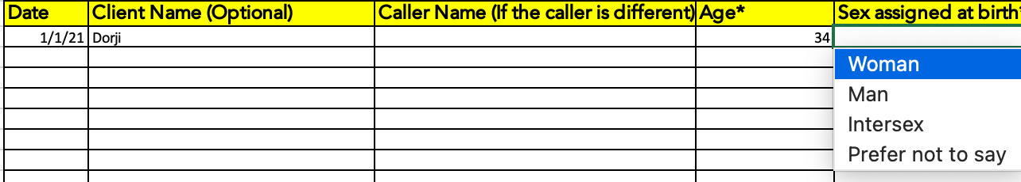

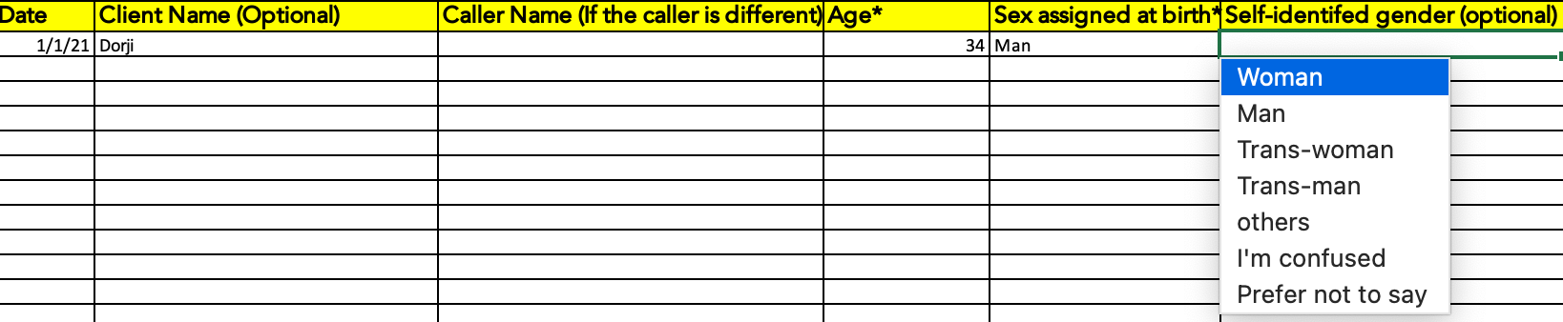

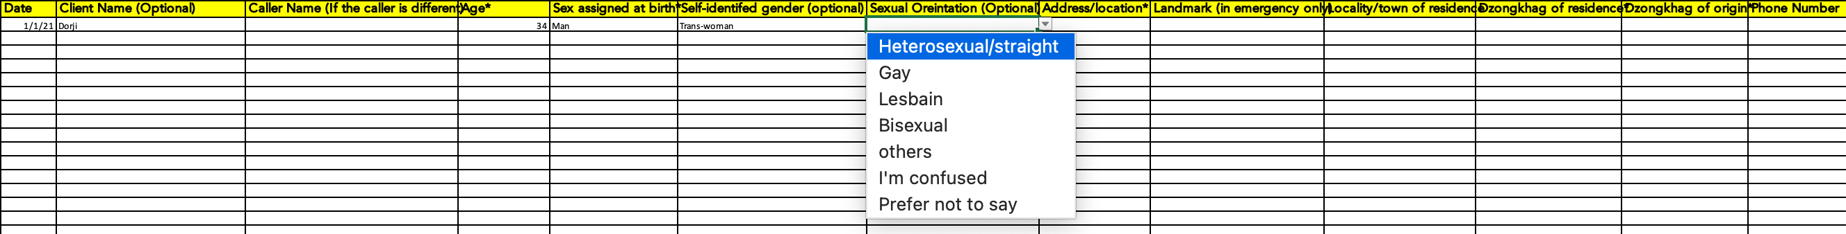

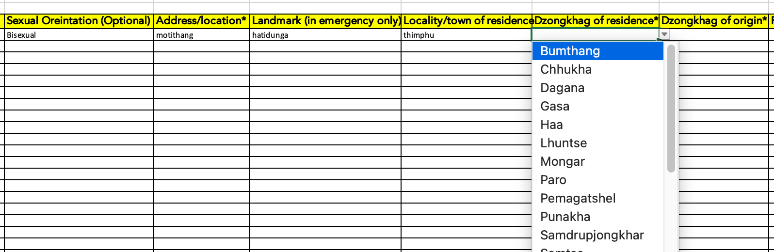

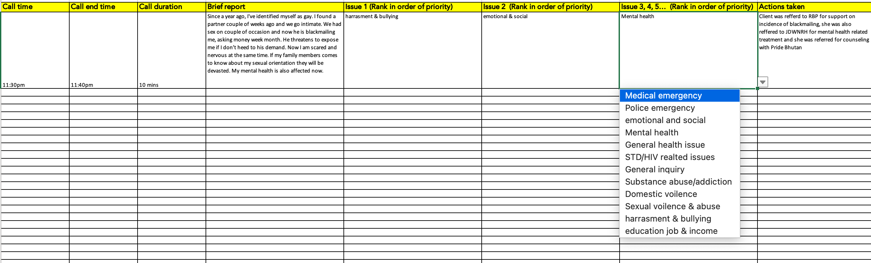

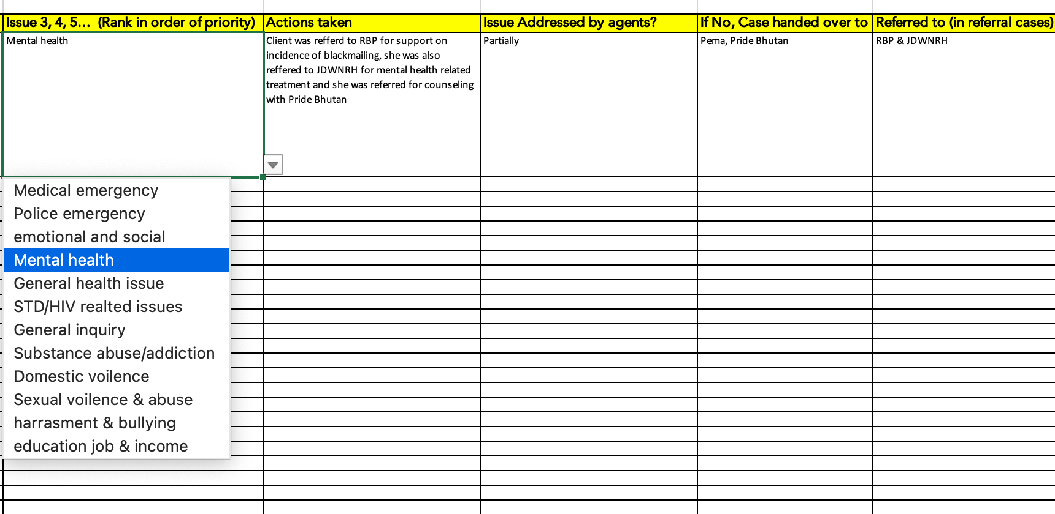

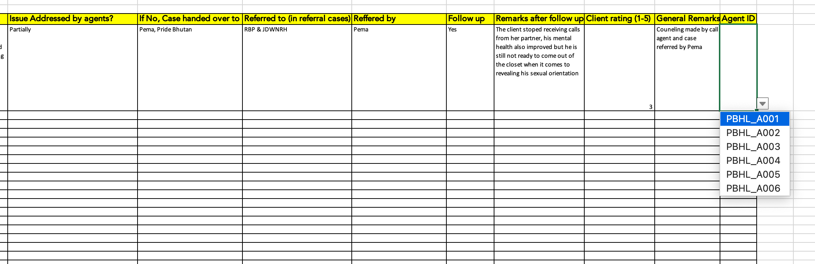

Figure 4: call record register sample

The supervisors shall compile the monthly report summarizing the call details in the following format (Table 3-Table 9) which is also annexed (Annexure IV).

* **General summary**

|  |  |
| --- | --- |
| **Summary** | **Total** |
| Total calls received |  |
| AVG calls/day |  |
| Total call duration |  |
| AVG duration/call |  |
| Referrals |  |
| Counseling |  |
| Follow-up made |  |
| Emergencies |  |

Table 3: call summary

* Agent summary

|  |  |
| --- | --- |
| **Agent code** | **Total calls attended** |
|  |  |
|  |  |
|  |  |
|  |  |
|  |  |
|  |  |
|  |  |
|  |  |
|  |  |
|  |  |
|  |  |

Table 4: agent summary

* Location-wise summary

|  |  |  |  |
| --- | --- | --- | --- |
| **Dzongkhag of Residence** | **Total** | **Dzongkhag of origin** | **Total** |
| Bumthang |  | Bumthang |  |
| Chhukha |  | Chhukha |  |
| Dagana |  | Dagana |  |
| Gasa |  | Gasa |  |
| Haa |  | Haa |  |
| Lhuntse |  | Lhuntse |  |
| Mongar |  | Mongar |  |
| Paro |  | Paro |  |
| Pemagatshel |  | Pemagatshel |  |
| Punakha |  | Punakha |  |
| Samdrupjongkhar |  | Samdrupjongkhar |  |
| Samtse |  | Samtse |  |
| Sarpang |  | Sarpang |  |
| Thimphu |  | Thimphu |  |
| Trashigang |  | Trashigang |  |
| Trashiyangtse |  | Trashiyangtse |  |
| Trongsa |  | Trongsa |  |
| Tsirang |  | Tsirang |  |
| Wangduephodrang |  | Wangduephodrang |  |
| Zhemgang |  | Zhemgang |  |

Table 5: location summary

* Gender-wise summary

|  |  |
| --- | --- |
| **sex at birth** | **Total** |
| Male |  |
| Female |  |
| Inter-sex |  |
| others |  |
|  |  |
| **Self-assigned sex** | **Total** |
| Male |  |
| Female |  |
| Trans-man |  |
| Trans-women |  |
| others |  |
|  |  |
| **Sexual orientation** | **Total** |
| Lesbain |  |
| Gay |  |
| Bisexual |  |
| Heterosexxual |  |

Table 6: gender and SOGIE summary

* Age-wise summary

|  |  |
| --- | --- |
| **Age group** | **Total** |
| 0-10 |  |
| 11-15 |  |
| 16-20 |  |
| 21-25 |  |
| 26-30 |  |
| 31-35 |  |
| 36-40 |  |
| 41-45 |  |
| 46-50 |  |
| 51-60 |  |
| 60 and above |  |

Table 7: age summary

* Top issue/case of the month

|  |  |  |
| --- | --- | --- |
| **Ranking** | **Issue** | **Total** |
| 1 |  |  |
| 2 |  |  |
| 3 |  |  |
| 4 |  |  |
| 5 |  |  |

Table 8: Issue summary

* Top referral agency

|  |  |  |
| --- | --- | --- |
| **Ranking** | **Agency Name** | **Total** |
| 1 |  |  |
| 2 |  |  |
| 3 |  |  |
| 4 |  |  |
| 5 |  |  |

Table 9: referral summary

# Annexure I: Template for MoU

**Memorandum of Understanding (MOU)**

**Between  
Pride Bhutan   
and  
[*Organisation X*]**

In an effort to strengthen services for *Key population* and to ensure appropriate, safe and quality services to the Pride Bhutan tollfree helpline callers, this Memorandum of Understanding defines areas of cooperation and activity between Pride Bhutan and [*Organisation x*]. The parties agree to the following

Pride Bhutan agrees to:

1. Continue to provide 24-hour telephone crisis intervention, message relay and information and referral services to key population and their family members in and around the country.
2. Provide referrals to [*Organisation X*] as appropriate, in accordance with the information provided by [*Organisation X*].
3. Provide Pride Bhutan outreach and educational materials to [*Organisation x*] to utilize within its organizational outreach effort.
4. Provide community-based referrals for information and direct services for Key population. and
5. Coordinate access to the Pride Bhutan programs and services
6. Provide consultation and support to [organization X] in regard to key population.

In exchange, [*Organization X*] agrees to:

1. Provide services for Pride Bhutan’s referral cases relevant to [organization X]
2. Be available by phone or other electronic means whenever [organization x’s] services are sought
3. Provide a link for Pride Bhutan tollfree helpline in your website.
4. Advise Pride Bhutan helpline as soon as possible, of any substantive changes in the descriptions of programs offered or demographic populations served by [*Organisation x]*.

The Pride Bhutan and [*Organisation x*] jointly agree to

11. Communicate, at least once a year, to review support provided to cases and update program information of both the entities and identify areas for improvement.

Term of Agreement

This MOU becomes effective on the date it is signed by representatives of both parties and will end [*Month Day, Year*], except that either party may end the MOU by giving a 30-day written notice to the other.

# Annexure II: Contact list of referral service providers

|  |  |  |  |  |
| --- | --- | --- | --- | --- |
| **Agency** | **Focal person** | **Designation** | **Email** | **Contact no.** |
| Ability Bhutan Society | Namgay Dorji | Program Officer | [namgayleo@gmail.com](mailto:namgayleo@gmail.com) | +9752340747/ 17562703/ 77652188 |
| Youth Development Fund | Roma Pradhan | Sr.Program Coordinator | romapradhan@bhutanyouth.org | 02-327483 Extension- 122 |
| Chithuen Phenday Association | Dawa Penjor | Program officer | [drukchithuen@gmail.com/](mailto:drukchithuen@gmail.com/) dawap46@gmail.com | 9752333111/  17279731 |
| Lhak-Sam | Deyon Phuntsho | Program officer | deyonphuntsho@gmail.com | +975 17855737 / 77261549 |
| Loden Foundation | Namgay Lhendup Wangchuk  Lhakpa | Education division  Entrepreneurship division | nwangchuk@loden.org  Lhakpa@loden.org |  |
| Adolescent- Friendly Health services, MoH | Tashi Yangchen | Program officer | tashiy@health.gov.bt | 17730189 |
| National HIV, Aids and STI Control Program (NACP), MoH | Leki Khandu, | Sr. Program Officer, | lkhandu@health.gov.bt | 17624153 |
| Emergency Medical Service Division, MoH | Ugyen Tshering | Sr. Program Officer | [utshering@health.gov.bt](mailto:utshering@health.gov.bt) | 17500270  112 (for HHC) |
| Department of Civil Registry and Census, MoHCA | Sherab Choki, | Civil Registration and Census officer |  | 97517382173/  325577 |
| Department of Immigration, MOHCA | Tawchu, | Sr. Immigration Officer |  | 97517611203/333873 |
| Ministry of labour and Human Resources | Jamyang Tshomo,  +, | Planning Officer/GFP | [kgyelmo@molhr.gov.bt](mailto:kgyelmo@molhr.gov.bt) | 975-2-333867(#2309)/17897744 |
| Ministry of education | Dochu | Chief PPD | dochu@moe.gov.bt |  |
| NCWC | Tashi Dorji | Offtg.head, protection services | tdorji@ncwc.gov.bt | 17867214 |
| RENEW | Kasang Dolkar | counseling head/CFP |  | +97519646407/332159 |
| RBP | Officer Commanding of all PS | - |  | +97519646407/332159 |

# Annexure III: Call record register template

Attached as xls file (sheet 1)

# Annexure IV: Monthly reporting template

Attached as xls file (sheet 2)